DARE HEAR Summary Report 2022

DARE and HEAR are higher education admissions schemes which aim to achieve equality of access by providing reduced points places to school leavers. These schemes were developed by a number of universities and colleges over 10 years ago to mitigate the negative impact socio-economic disadvantage and/ or disability can have on progression to and participation in higher education. Both of these groups have been identified in the National Access Plan and Priorities 2022-28 published earlier this year.

We are delighted that 2023 will see NCAD admit their first students via DARE and HEAR. Indeed their inclusion means that the 2022/23 cycle sees DARE and HEAR in operation in all public higher education institutions in the country. All 21 participating HEIs reserve a minimum of 5% of their places for reduced points offers for each of DARE and HEAR. In 2022, almost 1 in 5 students who applied to CAO on the basis of their Leaving Certificate (and were under 23) were assessed for DARE and or HEAR eligibility. A total of 11,018 offers were made to DARE and HEAR applicants across the entire Irish higher education sector (some applicants received both a Level 8 and a Level 6/7 offer)

DARE

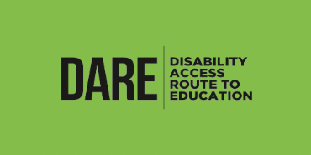***DARE is a third level alternative admissions scheme for school-leavers whose disabilities have had a negative impact on their second level education. DARE offers reduced points places to school leavers who, as a result of having a disability, have experienced additional educational challenges in second level education. In order to be eligible for DARE applicants must fulfil the following criteria:***

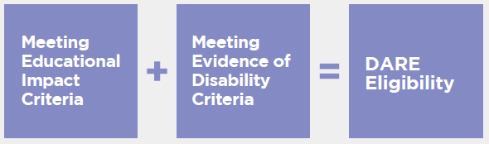

Each participating college has a reserved number of places to offer eligible DARE applicants at reduced Leaving Certificate points. The number of reduced points places available differs college by college, and course by course. The reduction in points can likewise vary every year and is dependent on a number of factors:

1. The overall number of places on the course

2. The number of reserved DARE places on the course

3. The number of DARE eligible applicants competing for these reserved places

4. The Leaving Certificate performance of DARE eligible applicants in that year

DARE Applications, Offer and Acceptances 2022

The number of applications to DARE, offers of college places and acceptances of those places continues to grow. In 2022, the and the number of completed applications (ie those who completed the application form and provided supporting documentation) to DARE grew by 8% from 2021 (and has increased 19% since 2020). . In 20222, 80% of applicants to DARE met the eligibility criteria (the same % as in 2020) but compared to just 52% in 2010. This is evidence of that our improved communications, outreach and processes have had a positive impact.

Like other CAO applicants, those applying to DARE can receive two offers (one at Level 8 and one at Level 6/7) but can only accept one of those offers. In 2022, 6102 DARE applicants received an offer of a place in higher education with 3676 accepting their offer. Of this figure, 1446 accepted a reduced points offers, whilst an additional 2230 eligible DARE applicants already achieved on or above the points required for their preferred course. For those applicants receiving a reduced points CAO offer, this offer was either for a course higher on their list of CAO preferences than their points would normally permit, or where they would not have received any offer at all. Irrespective of which type of offer was accepted, DARE-eligible entrants can receive disability supports at their college.

HEAR



***The Higher Education Access Route (HEAR) is a third level admissions scheme which offers places on reduced points and extra college support to school leavers from socio-economically disadvantaged backgrounds. In order to be eligible for HEAR applicants must fulfil the following criteria:***

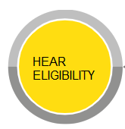

=

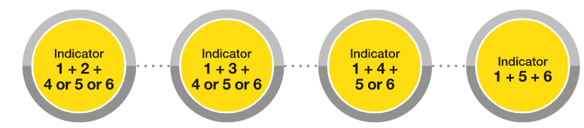

**Eligibility Indicators**

**1. Income**

**2. Medical Cards**

**3. Means-Tested Social Welfare Payment**

**4. Socio-Economic Group**

**5. School**

**6. Area**

HEAR Applications, Offer and Acceptances 2022

In 2022, 60% of HEAR applicants met the eligibility criteria, compared to 54% in 2010. This higher eligibility rate is the result of improved communications to students, parents/guardians and schools as well as user-friendly developments in the HEAR application processes.

HEAR is the only higher education admissions route that seeks to offer applicants who are foster children or separated children and/or in the care of TUSLA, the opportunity to gain access to third-level. In 2022, 167 such applicants were eligible for the scheme with 128 receiving an offer of a place in Higher Education.

In 2022, 3619 individual applicants to HEAR received an offer of a place in higher education (representing a 3% decrease on the number of offers made in 2021), with 2363 accepting their offer. Of the 3619 offers made, 1010 reduced-points offers were made to HEAR eligible applicants who had not met the normal points requirements for their preferred course, while 1363 additional offers were made to those HEAR eligible applicants who achieved on or above the points required).

Prioritisation

Our research has identified that two particular groups of students face the greatest obstacles when it comes to progression to higher education:

a) students with disabilities who are also from disadvantaged socio-economic backgrounds;

b) students with physical disabilities, are blind/vision impaired or are deaf/hard of hearing.

In order to increase the opportunities for these students in higher education, colleges participating in DARE and HEAR have agreed to prioritise these groups under the schemes.

In 2022, the number of applicants eligible for both DARE and HEAR was 365 with 239 accepting a place. Of the 158 applicants who are Deaf/Hard of Hearing who received an offer, 102 of them accepted a place in higher education, while 70 offers were made to students who are Blind/Vision Impaired, of whom 46 accepted a place.

Key DARE and HEAR Statistics 2022

* 20% of all 2022 CAO applicants made an online DARE or HEAR application (1 in 5)
* Over 5600 DARE and HEAR applicants accepted a place in Higher Education in 2022
* 15% increase in the number of offers to applicants who were eligible for DARE, compared to 2021
* 3% decrease in the number of offers to applicants who were eligible for HEAR, compared to 2021

Spotlight On

**Rachel Murphy – Trinity College Dublin (TCD)**

“I am a final year history student in Trinity College Dublin. Applying for DARE was a great decision as I have been supported through every step of my college so far because of the link it gave me to the Trinity Disability Service. I received a variety of supports like extra time in exams, a low-distraction venue and Occupational Therapy.

A highlight of my college experience has been joining societies and making friends with similar interests from first year onwards. I am also a member of the Trinity Ability Co-op which is a cooperative movement led by disabled students towards radical inclusion in Trinity. Through this I have worked on the Towards Inclusive Clubs and Societies Project to make clubs and societies more inclusive to disabled students.

My experience as a student with a disability in Trinity has been very positive, thanks to the Disability Service and the vibrant disability community on campus.”

**Kealan Begley Schade – Galway-Mayo Institute of Technology (GMIT)**

“I first learned of HEAR in an off-chance meeting with my guidance counsellor, a former teacher of mine. I had struggled for years with depression & anxiety as it impacted my academic pursuits.

When I was told of HEAR & my guidance counsellor helped me apply, I immediately had hope, that even if I could not perform as well as I would have liked in my Leaving Cert due to these troubles, I could still turn a new leaf and get into college. HEAR not only helped me get into college but supported me long after and continues to do so.

I've received help in forms of a student mentor who I could speak to frequently, financial bursaries, study support & I've frequently been informed that if I need help with anything, I need only ask. This has given me quite a secure safety net in all manners. I've since joined several clubs, namely Rugby & HEMA (Historical European Martial Arts). I'm happy, active & busy for the first time in a long time.”

