Annotated Template

For the 2018 call, applicants must submit Part B of their proposal as two separate documents:

- Part B1 (32 pages maximum)
- Start Page (1 page)
- 1. Table of Contents (1 page)
- 2. Excellence
- 3. Impact
- 4. Implementation

- Part B2 (No overall page limit)
- 5. References
- 6. Participating Organisations Tables
  - Data for non-academic beneficiaries
  - Beneficiaries (MS/AC) 1 page maximum
  - Partner Organisations (TC) 1 page maximum
- 7. Ethics Issues
- 8. Letters of Commitment from Third Country Partner Organisations 1 page maximum

- Proposal Submission Process

MANDATORY FORMATTING REQUIREMENTS
Body Text Font Size | 11 points minimum
Table Font Size | 9 points minimum
Page Margins | 15 mm minimum (not including headers and footers)
Literature References | Please provide a numbered list in Section 5
Required Header | PROPOSAL ACRONYM - RISE
Page Number Format | Page X of Y

Text inserted by the NCP is in red throughout the document. Text is intended to provide guidance only, and is not exhaustive.

The yellow “EU Policy Boxes” provide a menu of excerpts from EU policies which you can choose from to make a tangible link between your programme and those policies.

START PAGE

Marie Skłodowska-Curie Actions

Research and Innovation Staff Exchange (RISE)
Call: H2020-MSCA-RISE-2018

PART B

“PROPOSAL ACRONYM”
Use a memorable acronym – a real word – you can use online acronym generators to help. Check http://cordis.europa.eu/projects/home_en.html to see if an EU project with the same acronym already exists.
Proposal Title and Logo (if available)
Table of Contents (max. 1 page)
Please insert a full table of contents with page numbers, including main headings and sub-headings. Include the sections from Document 1 and Document 2.
In drafting PART B of the proposal, applicants must follow the structure outlined below.

DOCUMENT 1 (MAX 32 PAGES)
START PAGE (MAX 1 page)
1 TABLE of CONTENT (MAX 1 page)
START page count (max 30 pages SECTIONS 2-4)

2. EXCELLENCE (starting page 3)
3. IMPACT
4. QUALITY AND EFFICIENCY OF THE IMPLEMENTATION

STOP page count (MAX 30 PAGES Sections 2-4)

DOCUMENT 2 (NO OVERALL PAGE LIMIT APPLIED)
5. REFERENCES
6. Capacities of the participating ORGANISATIONS
7. ETHICS ASPECTS
8. Letters of commitment oF TC partner organisations
END PAGE (1 page)

Please note that:

- Applicants must ensure that document 1 does not exceed the total page limit of maximum 32 pages (1 start page + 1 table of content page + 30 pages for Sections 2-4).
- No reference to the outcome of previous evaluations of this or any similar proposal should be included in the text. The expert evaluators will be strictly instructed to disregard any such references

EU Policy Box 1
- “Charter and Code”: The European Charter for Researchers and Code of Conduct for their Recruitment,
http://ec.europa.eu/euraxess/index.cfm/rights/whatIsAResearcher.
The “Charter and Code” principles are mainstreamed into the MSCA. Everyone applying for MSCA funding should read the C&C.
Some principles which are particularly relevant to RISE (not exhaustive) are:
- Employers and/or funders of researchers should ensure that the most stimulating research or research training environment is created which offers appropriate equipment, facilities and opportunities, including for remote collaboration over research networks. Particularly relevant to the Excellence section (2.1 research programme, 2.2 training programme) and the Implementation section (2.3 Infrastructure)

- Employers and/or funders of researchers should draw up, preferably within the framework of their human resources management, a specific career development strategy for researchers at all stages of their career, regardless of their contractual situation, including for researchers on fixed-term contracts. It should include the availability of mentors involved in providing support and guidance for the personal and professional development of researchers, thus motivating them and contributing to reducing any insecurity in their professional future. All researchers should be made familiar with such provisions and arrangements. Particularly relevant to the Excellence section (2.3 supervision).

- Employers and/or funders must recognise the value of geographical, intersectoral, inter- and trans-disciplinary and virtual mobility as well as mobility between the public and private sector as an important means of enhancing scientific knowledge and professional development at any stage of a researcher's career. Consequently, they should build such options into the specific career development strategy and fully value and acknowledge any mobility experience within their career progression/appraisal system. Particularly relevant to the Excellence section (2.2 training programme, 2.4 interaction between the participants) and the Impact section (3.2 Structuring research training-contribution of the non-academic sector).

- Employers and/or funders should ensure that a person is clearly identified to whom early-stage researchers can refer for the performance of their professional duties, and should inform the researchers accordingly. Particularly relevant to the Excellence section (2.3 supervision).

- Employers and/or funders of researchers should recognise it as wholly legitimate, and indeed desirable, that researchers be represented in the relevant information, consultation and decision-making bodies of the institutions for which they work, so as to protect and promote their individual and collective interests as professionals and to actively contribute to the workings of the institution. Particularly relevant to the Implementation section (4.2 management).

START page count – MAX 30 pages

2. Excellence
2.1 Quality and credibility of the research/innovation action; level of novelty and appropriate consideration of inter/multidisciplinary, intersectoral and gender aspects
Please develop your proposal according to the following lines:
2.1.1 Specific objectives and the relevance of the research and innovation action including its potential for scientific breakthroughs in relation to the "state of art". The methodology, transfer of knowledge, secondments, training, dissemination, work plan, etc. described in the rest of the proposal must relate to research and innovation objectives described in this section.
- Start with a short paragraph summarising the overall RISE programme, such as:
“The overarching objective of this RISE programme is to form an international and inter-sectoral network of organisations working on a joint research programme in the fields of X and Y. The participants will exchange skills and knowledge which will allow them to progress towards key advances in Z, and strengthen collaborative research between in different countries and sectors. Advances in Z will have potential market opportunities for non-academic participants in the project / have significant benefit for European society. The staff members who participate in the project will develop new skills, be exposed to new research environments and have their career perspectives widened”
- Outline the key specific Research Objectives of the programme (use a bulleted list, text box or table to make them stand out)
- Describe how the objectives relate to the “scope of the call”
  - Why do you need to work together on this research?
  - How will the project “foster a shared culture of research and innovation” as outlined in the MSCA Work Programme 2018-2020?
- Describe the State of the Art and how the objectives relate to it
- Include a list of bibliographic references (Section 5)
  - Make sure to cite consortium members (“you are the experts”)

2.1.2 Methodological approach: detail the research and innovation activities proposed and their originality.
2.1.3 Inter/multidisciplinary types of knowledge involved, where applicable.
2.1.4 Gender aspects in research activities where human beings are involved as subjects or end-users, gender differences may exist. In these cases the gender dimension in the research content has to be addressed adequately.
- In research activities where human beings are involved as subjects or end users, gender differences may exist. If this applies to your research programme, you must briefly explain how you have taken gender into account in the research methodology described in 2.1.2 e.g. using animal models of both gender, separation of research subjects into male and female groups. Some examples of the gender dimension in different research areas are:
  - Health: Osteoporosis research in men https://genderedinnovations.stanford.edu/case-studies/osteoporosis
  - Engineering: Assistive Technologies for the Elderly http://genderedinnovations.stanford.edu/case-studies/robots.html
  - Environment: Public Transportation
http://genderedinnovations.stanford.edu/case-studies/transportation.html
- Explain the gender balance in the secondment programme and at decision-making level in the project. NB: refer back to this section for details on gender balance in decision making when you are writing section 4.1

Common Weaknesses in unfunded RISE applications:
- The innovative aspects of the proposed research are insufficiently articulated.
- The innovative nature of the project has not been explained thoroughly enough as the proposed research has not been fully linked to the state of art in the field.
- The level of novelty of the proposed methodology is relatively limited.
- The research method does not provide a clear explanation of the interaction between the different work packages, lacking of focus due to the large number of heterogeneous tasks and the significant dispersion of resources.

EU Policy Box 2
- Gender in Horizon 2020
Gender equality is a cross-cutting issue in Horizon 2020 and shall be implemented across all areas of Horizon 2020, including the MSCA. This will extend to promoting the gender dimension in research and innovation content. Gender equality is also included in Horizon 2020 monitoring and evaluation exercises.
Key objectives include:
- Gender balance in decision-making: The aim is to reach the Commission’s target of 40% of the under-represented sex in each group and panel. For Horizon 2020 Advisory Groups, the target was raised to 50%, given the high response rate from women to the Commission’s call for interest launched in February 2013.
- Gender balance in research teams at all levels: Applicants for funding are encouraged to promote equal opportunities and to ensure a balanced participation of women and men at all levels in research and innovation teams and in management structures. Gender balance in teams will also be taken into account when ranking proposals with the same evaluation scores.
- Gender dimension in research and innovation content: Gender is explicitly integrated into several topics across the Horizon 2020 Work Programme. Topics with an explicit gender dimension are flagged, to ease access for applicants, but all H2020 applications should take the gender dimension into account.
Factsheet: https://ec.europa.eu/programmes/horizon2020/sites/horizon2020/files/FactSheet_Gender_2.pdf
Document: Gendered Innovations – How Gender Analysis Contributes to Research http://ec.europa.eu/programmes/horizon2020/en/news/%E2%80%9Cgendered-innovations-how-gender-analysis-contributes-research%E2%80%9D
Gender Toolkit
http://www.yellowwindow.be/genderinresearch/index_downloads.html
The European Commission sponsored the development of a Gender Toolkit for FP7 by Yellow Window Management Consultants. The documents are freely available on the web, and include an overview of gender in research, a checklist for help in preparing grant applications, and detailed, discipline specific, documents examining the role of gender.
European Institute for Gender Quality (EIGE)
EIGE is an autonomous body of the European Union, established to contribute to and strengthen the promotion of gender equality, including gender mainstreaming in all EU policies and the resulting national policies, and the fight against discrimination based on sex, as well as to raise EU citizens’ awareness of gender equality.
EIGE also assists EU institutions and the Member States in the collection, analysis and dissemination of objective, reliable and comparable information and data on equality between women and men. You may find useful statistics for use in your proposal at:
http://eige.europa.eu/gender-statistics

Table B1 – Work Package (WP) List
Minimum font size for tables is 9 points. Aim for something that is readable when printed out as well as on screen.

Work Package No | Work Package Title | Activity Type (e.g. Research, Training, Management, Communication, Dissemination…) | Number of person-months involved | Beneficiary leading | Start Month | End month

The title of the scientific WPs should give a good idea of the scope of the research/innovation objectives of that WP.
- Insert the provided WP Table B1 at the start of this sub-section.
- Break down the research programme into (typically) three or four discrete research Work Packages that relate to the Research Objectives described above.
- Give a one-paragraph summary (aim for 10-12 lines of text) of each Work Package here – the corresponding full Work Package table should go in Section 4.1.
- Methodology: in the Work Package descriptions, ensure to describe in detail how the objectives in the research programme will be explored - equipment, techniques, assays, types of research etc. You need to provide enough information so that the evaluator can understand how you will tackle the problem at hand, and can clearly see what is novel/interesting about your particular approach.

2.2 Quality and appropriateness of knowledge sharing among the participating organisations in light of the research and innovation objectives
Please develop your proposal according to the following line:
2.2.1 Approach and methodology used for knowledge sharing (secondments, workshops/trainings/conferences, etc.). It should be clear how the knowledge sharing will directly contribute to achieving the aims of the research and innovation activities described in section 2.1.
- Spell out the knowledge-sharing objectives w.r.t. the research objectives, i.e. what knowledge will you share with each other and how will these help you achieve the research objectives?
- Describe the overall strategy for knowledge-sharing and explain why the elements of the strategy are appropriate to facilitate knowledge-sharing
  - Secondment programme
  - Networking events e.g. workshops/training/conferences
- Detail the Secondments which will take place
  - How will they contribute to the knowledge-sharing objectives?
  - Identify the knowledge provider and the recipient of the knowledge
  - Specify what knowledge will be transferred during each secondment
  - How will secondees transfer knowledge whilst on secondment, and how will they embed that knowledge into their home organisation when they return?
  - Tip: Make sure both ESRs (pre-PhD) and ERs are doing secondments (longer visits >4 months for ESRs are preferred by evaluators)
  - “A picture tells a thousand words” – use a diagram to show the flow of people around the consortium
  - Could include a table of the type shown below to summarise all the information. Ensure that the numbering system used in Column 1 below to represent the individual staff members matches that in Table A3.1 in the Part A online form.

Researcher Number and Type | From | To | Duration [months] | Timing [Mx – My] | Purpose | Transfer Mechanism | Reintegration Mechanism
1 – ESR |  |  |  |  |  | Research work | Return to PhD programme
2 – ER |  |  |  |  |  | Research work | Seminar open to Department
3 – MNG |  |  |  |  |  | Attending Workshop | Delivering workshop in sending organisation
4 – TECH |  |  |  |  |  | Demonstration of equipment | Return to role in sending organisation
5 - ESR |  |  |  |  |  | Research work | Workshop for research group

Common Weaknesses in unfunded RISE applications:
- The knowledge sharing strategy is not fully convincing:
- The participants’ interactions are not sufficiently emphasized in terms of content and expertise provided to reach the project’s objectives.
- The inter-sectoral dimension of the proposed networking activities is limited.
- The contribution of each participant in the planned activities is not properly outlined.
- There is an over-emphasis on exchanged ERs giving lectures, and on research tasks as opposed to transfer of knowledge objectives.
- The knowledge sharing among the participants is not sufficiently described, and does not provide enough detail regarding the specific activities to be developed by each secondment.
- The goals of the annual workshops are not sufficiently described in terms of networking and knowledge transfer.
- Limited information is provided on how the knowledge will be spread between the partners, since it does not explain the methodology used for knowledge sharing and the presentation of interactions is confusing and not sufficiently consistent.

2.3 Quality of the proposed interaction between the participating organisations
Please develop your proposal according to the following lines:
2.3.1 Contribution of each participating organisation in the activities planned and expertise provided to reach the action’s objectives, with particular emphasis on the scientific objectives described in section 2.1.
- Clearly state what each participating organisation will contribute towards achieving the research and knowledge transfer objectives – use a table for brevity and clarity
- Include their expertise, their contribution to networking events, and their level of participation in the secondments
2.3.2 Justification of the main networking activities.
- Describe the networking activities that will be organised to share knowledge e.g. workshops, meetings, trainings, online networking and knowledge sharing
- Justify how these will contribute to the knowledge-sharing objectives – explain why you have chosen these particular activities
- Outline the benefits of the knowledge-sharing to the participating organisations
Common Weaknesses in unfunded RISE applications:
- The justification of the networking activities lacks detail including specific actions and planning.
- The quality of interaction between the participating organizations is poorly addressed; (for instance: the justification of networking activities and the contributions in terms of content and expertise are not convincing).
- The quality of the interaction between the partners is not well presented in light of the scope of the project. Also, considering that the research programme involves several EU and one TC and both academic and industrial partners, the contribution for each participant is not sufficiently presented.

3. Impact
3.1 Enhancing the potential and future career prospects of the staff members
Please develop your proposal according to the following line:
3.1.1 Describe how the action contributes to realising the potential of individuals and provides new skills, enhances their knowledge and career perspectives.
- The overall aim is to show an understanding of how participating in the RISE project will help the Staff to enhance their potential and improve their career prospects
- Present an analysis of how participating will affect the Staff, e.g.:
  - New knowledge gained (e.g. research skills, transferable skills)
  - Mobility to academic/non-academic sector and/or organisations outside Europe (i.e. experiencing different research environments)
  - Improved understanding of the benefits of international and/or cross-sectoral research
  - Opening their eyes to new career options, particularly outside academia
  - Raising their profile through networking, research outputs and communication activities to different target groups (including the media & general public)
- Make a tangible link between your programme’s elements and EU policies about research careers/employability – Sample EU policies are embedded in the EU Policy Boxes throughout this handbook.
Common Weaknesses in unfunded RISE applications:
- The human resources development potential is described generically, without clear planning.
- 1 month long ESR secondments are deemed too short to create an impact in terms of providing new skills and career perspectives.
- It has not been convincingly described how the project will contribute to realising the potential of practitioners with new skills and career perspectives.
- The new career perspectives are not appropriately addressed, without a clear indication of what new opportunities in the job market will be result from this work.

EU Policy Box 3
- “Charter and Code”: The European Charter for Researchers and Code of Conduct for their Recruitment (see EU Policy Box 1)
- Europe 2020 Flagship Initiative – Agenda for new skills and jobs
http://ec.europa.eu/social/main.jsp?catId=738&langId=en&pubId=626&type=2&furtherPubs=yes
The Agenda, published October 2010, presents a set of concrete actions that will help:
- Stepping up reforms to improve flexibility and security in the labour market ('flexicurity')
- Equipping people with the right skills for the jobs of today and tomorrow
- Improving the quality of jobs and ensuring better working conditions
- Improving the conditions for job creation

Key points relevant to RISE:
- Providing the right mix of skills
- Matching people’s skills and job opportunities, and capitalising on Europe’s potential jobs
- Enhancing geographical mobility throughout the EU
- Promoting entrepreneurship, self-employment and innovation

- Europe 2020 Flagship Initiative – Youth on the Move
http://europa.eu/youthonthemove/docs/communication/youth-on-the-move_EN.pdf
Youth on the Move is a comprehensive package of policy initiatives on education and employment for young people in Europe. Launched in 2010, it aims to improve young people’s education and employability (specific focus on reducing youth unemployment) by:
- making education and training more relevant to young people's needs;
- encouraging more of them to take advantage of EU grants to study or train in another country;
- encouraging EU countries to take measures simplifying the transition from education to work.

Key points relevant to RISE (Section 3.1):
- Supporting a strong development of transnational learning and employment mobility for young people
- Supporting young entrepreneurs and self-employment

EU Policy Box 4
- Mobility of Researchers between Academia and Industry: 12 Practical Recommendations
https://cdn5.euraxess.org/sites/default/files/policy_library/mobility_of_researchers_light.pdf
Although this document was published over ten years ago (2006), it still contains recommendations that are relevant to researchers moving between academia and industry (non-academia).
Some recommendations relevant to RISE 2018 are:
- Developing joint training programmes to better address future employers’ needs
- Preparing early stage researchers for a career in both sectors, including developing entrepreneurial skills.
- Providing supervision quality insurance, in particular for early stage researchers.
- Increasing inter-sector mobility possibilities for both early stage and established researchers.
3.2 Developing new and lasting research collaborations, achieving transfer of knowledge between participating organisations and contribution to improving research and innovation potential at the European and global levels
Please develop your proposal according to the following lines:
3.2.1 Describe the development and sustainability of new and lasting research collaborations resulting from the intersectoral and/or international secondments and the networking activities implemented.
- Explain how the secondments and networking activities and the knowledge-transfer achieved via those mechanisms will help to develop a lasting collaboration between the participants.
- Relate this to EU policies on international and inter-sectoral collaboration in Research & Innovation – pay particular attention to EU Policy Boxes 4 & 5.
- Outline your plans for building the collaboration and continuing it after the RISE project has ended.

3.2.2 Describe the contribution of the action to the improvement of the research and innovation potential within Europe and/or worldwide.
- Explain how the research programme and the Staff’s activities (including dissemination/exploitation/communication/outreach activities) will contribute to Europe’s economy and/or society
- Make a link to EU research/policy goals such as Horizon 2020 Societal Challenges or Industrial Leadership Pillar, Research Roadmaps, EU policies on e.g. health, immigrants, digital economy, all available online (Google search)
- Could your research contribute to the development of a new European Standard? If yes, describe this briefly here and explain the details in Section 3.3 under ‘Exploitation’. See http://www.cencenelec.eu/research/Pages/default.aspx for details of European standardisation under Horizon 2020.
- Recall that ideally 35% of the H2020 budget will be spent on climate action and 60% on sustainable development. Can you make a realistic link to either or both of those areas?
- Climate Action includes:
  - mitigating climate change (helping to cut greenhouse gas emissions)
  - adapting to the impact of climate change by building resilience to phenomena such as flooding, droughts and other extreme weather events
  - contributing to understanding the causes of climate change.
  - Activities contributing to climate action are listed in the Horizon2020 Online Manual
- Sustainable Development is development that meets the needs of the present without compromising the ability of future generations to meet their own needs within the planet's physical boundaries. Sustainable development has economic, social and environmental dimensions:
  - Economic - providing economic added value through new technologies, products, services, governance or business models that improve competitiveness and prosperity, and promoting job creation or safeguarding jobs, together with related policies.
  - Social - addressing and improving human health, quality of life, safety and security of individuals and populations, culture, skill formation, social integration and inclusion, poverty reduction, effective and democratic governance, and related policies.
  - Natural - protecting, reducing/preventing degradation of, or restoring natural resources and ecosystems (e.g. air, water, forests, soil), and the biodiversity that underpins them.
  - For more information, see the Horizon 2020 Online Manual.⁸ The image below outlines the 17 UN Sustainable Development Goals.
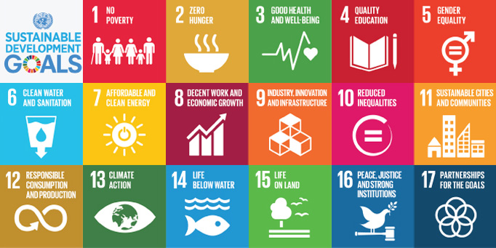

EU Policy Box 5
- Enhancing and focusing EU international cooperation in research and innovation: a strategic approach
http://ec.europa.eu/research/iscp/index.cfm?lg=en&pg=strategy
This document outlines the EU’s key objectives of international cooperation in R&I:
- Strengthening the Union’s excellence and attractiveness in research and innovation as well as its economic and industrial competitiveness – by creating win-win situations and cooperating on the basis of mutual benefit; by accessing external sources of knowledge; by attracting talent and investment to the Union; by facilitating access to new and emerging markets; and by agreeing on common practices for conducting research and exploiting the results;
- Tackling global societal challenges – by developing and deploying effective solutions more rapidly and by optimising the use of research infrastructures;
- Supporting the Union’s external policies – by coordinating closely with enlargement, neighbourhood, trade, Common Foreign and Security Policy (CFSP), humanitarian aid and development policies and making research and innovation an integral part of a comprehensive package of external action.

Common Weaknesses in unfunded RISE applications:
- The proposal does not demonstrate the potential for the extension of long term collaborations beyond the existing ones.
- The impact of the project on improving research and innovation potential at the European and global levels is weakly justified in the proposal, or is limited by too narrow a focus and lacks a more translational focus.
- It is evident that some partners have been made to fit into the project but with a weak connection.
- As most of the partners have already participated in previous collaborations, the added value of the research, in the sense of the knowledge sharing, is not clearly articulated.
- ESR secondments are deemed short to create an impact in terms of knowledge transfer (<4 mths in duration).
- The lack of an industrial partner limits the potential impact on innovation in the academic environment.
- The establishment of new and additional collaborations beyond the already existing one is unclear, and is not supported by a comprehensive strategy that can adequately support the organizations to achieve it.

EU Policy Box 6
- Europe 2020 Flagship Initiative – Innovation Union
http://ec.europa.eu/research/innovation-union/index_en.cfm?pg=action-points
The Innovation Union, published October 2010, outlines over 30 action points with the aim to do three things:
- make Europe into a world-class science performer;
- remove obstacles to innovation – like expensive patenting, market fragmentation, slow standard-setting and skills shortages – which currently prevent ideas getting quickly to market; and
- revolutionise the way public and private sectors work together, notably through Innovation Partnerships between the European institutions, national and regional authorities and business.
The 30 IU commitments are broken down into chapters:
- Promoting excellence in education and skills development
- Delivering the European Research Area
- Focusing EU funding instruments on Innovation Union priorities
- Promoting the European Institute of Innovation and Technology (EIT) as a model of innovation governance in Europe
- Enhancing access to finance for innovative companies
- Creating a single innovation market
- Promoting openness and capitalising on Europe's creative potential
- Spreading the benefits of innovation across the Union
- Increasing social benefits
- Pooling forces to achieve breakthroughs: European Innovation Partnerships
- Leveraging our policies externally
- Reforming research and innovation systems
- Measuring Progress
It is clear that all commitments relevant to Horizon 2020 have been incorporated into the Horizon 2020 programme.
Specific IU Commitments which appear particularly relevant to RISE 2018:
- #1: By the end of 2011, Member States should have strategies in place to train enough researchers to meet their national R&D targets and to promote attractive employment conditions in public research institutions.
- #2: The Commission will also support business-academia collaborations through the creation of "Knowledge Alliances" between education and business to develop new curricula addressing innovation skills gaps (see also commitment 3 on e-skills). They will help universities to modernise towards inter-disciplinarity, entrepreneurship and stronger business partnerships.
- #7: The Commission will design future EU research and innovation programmes to ensure simple access and stronger involvement of SMEs, in particular those with a high growth potential.
- #20: The Commission will promote open access to the results of publicly funded research. It will aim to make open access to publications the general principle for projects funded by the EU research Framework Programmes. The Commission will also support the development of smart research information services that are fully searchable and allow results from research projects to be easily accessed
- #21: The Commission will facilitate effective collaborative research and knowledge transfer within the research Framework Programmes and beyond.
- #31: The European Union and its Member States should treat scientific cooperation with third countries as an issue of common concern and develop common approaches. This should contribute to global approaches and solutions to societal challenges and to the establishment of a level-playing field (removing barriers to market access, facilitating standardisation, IPR protection, access to procurement etc.).
3.3 Quality of the proposed measures to exploit and disseminate the action results
Before writing discuss with all beneficiaries about their own dissemination and exploitation channels/mechanisms.
Remember that Horizon 2020 is about bringing research “closer to the user”, so activities in Section 3.3 and 3.4 must target a broader audience than just your peers in your own research area.
Guidance on Dissemination and Exploitation can be found at
http://ec.europa.eu/research/participants/docs/h2020-funding-guide/grants/grant-management/dissemination-of-results_en.htm
Please develop your proposal according to the following lines:
3.3.1 Describe the dissemination strategy about the results - targeted at peers (scientific or the action's own community, industry and other commercial actors, professional organisations, policymakers) and to the wider research and innovation community - to achieve the potential impact of the action. Please provide adequate details and sufficient arguments for the choices of your planned activities.
- In Horizon 2020, dissemination is sharing research results with potential users - peers in the research field, industry, other commercial players and policymakers.
- Describe in detail what activities you will organise and participate in to disseminate the research results to this audience.
- State which target journals the results be published in and how many articles each staff will aim to produce.
- Describe which conferences the staff will attend and present at and how often.
- Describe activities targeted to other potential users e.g. attending trade shows to engage with industry, organising workshops for clinicians in healthcare-related projects etc.
- If you will participate in the Horizon 2020 Open Data Pilot, describe the potential impact of sharing your research data openly. See http://ec.europa.eu/research/participants/docs/h2020-funding-guide/cross-cutting-issues/open-access-dissemination_en.htm for more details.

3.3.2 Elaborate on how results (when available) will be taken up/used. Also the expected impact of the proposed exploitation, commercial application and dissemination measures.
- Describe the potential impact of disseminating to these audiences – it might be a different impact for each audience type. Describe the impact of learning about the research activities on the audience.
- Include quantifiable targets for measuring the impact of Dissemination Activities e.g. number of attendees at an event.

    - Expected impact of the proposed measures (e.g. addressing societal needs/challenges).

- Explain how (dissemination/exploitation activities) will contribute to Europe’s economy and/or society.

3.3.4 Indicate intellectual property rights aspects (if applicable) and exploitation of results.
- In Horizon 2020, exploitation is using results for commercial purposes or in public policymaking. There's a close link between dissemination and exploitation. Dissemination feeds into exploitation.
- Depending on the type of research area, the research results might be useful to business, to policymakers/society or to both.
- If the results are useful to business:
  - Outline plans to exploit any IP/commercial potential arising from the programme. Briefly describe the role of any Technology Transfer Office or similar in helping you to commercialise the results.
  - How have you decided to “allocate” IP in your consortium? The Model Grant Agreement outlines for the “MSCA rules” for IP. A simplified explanation is given in a short booklet offered by the IPR Helpdesk.
  - Remember that this is the Impact section. Describe the potential impact of exploiting the commercial potential of the research results.
- If the results are useful to policymakers/the wider society:
  - Outline what activities you will engage in to ensure that relevant policymakers/societal actors (community or voluntary sector) etc. will be informed about the research results. E.g. could you organise a special workshop or information event? For health-related projects, involvement of patient groups is becoming an unwritten requirement for successful projects, so please include them in your plans.
- Remember that this is the Impact section. Describe the potential impact of disseminating the research results to this audience.
- Include quantifiable targets for measuring the impact of IP/exploitation.

Common Weaknesses in unfunded RISE applications:
- The proposed measures for dissemination are not described in a sufficient manner.
- Dissemination activities are listed but the proposal lacks a clear dissemination strategy.

EU Policy Box 7
- ERA Communication 2012
http://ec.europa.eu/research/era/pdf/era-communication/era-communication_en.pdf
This document refocuses the European Research Area policy into five key priorities:
- More effective national research systems
- Optimal transnational co-operation and competition (On common research agendas, grand challenges and infrastructures)
- An open labour market for researchers (Facilitating mobility, supporting training and ensuring attractive careers)
- Gender equality and gender mainstreaming in research (Encouraging gender diversity to foster science excellence and relevance)
- Optimal circulation and transfer of scientific knowledge (To guarantee access to and uptake of knowledge by all)
Point 5 is essentially about open access to research publications and research data and is particularly relevant to sections 3.3 (Dissemination & Exploitation) and 3.4 (Communication & Public Engagement) of the proposal. A commitment to open access on behalf of all participants in the ITN (after any necessary procedure to protect Intellectual Property) would be well received by the evaluators. Open access to publications (green or gold model) is acceptable, and open access to research data through the Open Research Data Pilot would be additive https://www.openaire.eu/open-access-to-research-data-the-open-research-data-pilot-2

3.4 Quality of the proposed measures to communicate the action activities to different target audiences
Before writing discuss with all beneficiaries about their own communication and public engagement channels/mechanisms.
In Horizon 2020, Communication means promoting the programme and its results to multiple audiences (including the media and the public) in a strategic and effective manner. For more details see http://ec.europa.eu/research/participants/docs/h2020-funding-guide/grants/grant-management/communication_en.htm
Please develop your proposal according to the following lines:
3.4.1 Describe the communication strategy of the project and its results, outreach plan and the activities envisaged to engage the public. Please provide adequate details and sufficient arguments for the choices of your planned activities.
- Targeted at multiple audiences, beyond the project's own community (including the media and the public).
- From the beginning of the project, to inform and reach out to society, show the benefits of research.

3.4.2 Consider how activities will be targeted at multiple audiences, beyond the action's own community (including the media and the public).
- Communication is two-way from sender to receiver e.g. an article in a newspaper or on TV or radio
  - Describe the activities the consortium will perform to ensure media coverage about the programme and its results e.g. press releases to newspapers, feature articles in magazines. Is there any potential to have the programme featured on local/national TV or radio in any of the countries in the consortium?
  - Explain who will help you with seeking media coverage e.g. Communications Office/Officer.

3.4.3 From the beginning of the project, indicate which channel(s) will be used to inform and reach out to society, and to show the benefits of research.
- Public engagement is meant to engage a large audience and to bring knowledge and expertise on a particular topic to the general public.
- Describe what activities the consortium will perform to engage the general public about the activities of the project:
  - Plan a range of activities (e.g. social media, school visits, lab “open days” public talks) targeted at multiple audiences
  - Talk to experts at your institution. See what local/national activities you can join in e.g. Pint of Science, SFI Discover, European Researchers’ Night. Activities need to take place across the whole consortium, not just in Ireland, so ask your consortium participants for information on what activities they have in their organisation/region/country.
  - If applicable, explain who will help you with public engagement activities e.g. Education/Outreach Officer.
  - Details and suggestions for additional activities which you might include can be found at: http://ec.europa.eu/research/mariecurieactions/documents/documentation/publications/outreach_activities_en.pdf

3.4.4 Elaborate on the expected impact of the proposed activities.
- What is the potential impact of media coverage about the activities?
- What is the potential impact of engaging the public in the activities of the RISE?
- Include quantifiable targets for measuring the impact of communications & outreach/public engagement.

- Important! The following sections of the European Charter for Researchers refer specifically to outreach and dissemination: ensure that your plans align with these principles.
Communication
Researchers should ensure that their research activities – both the action and, when available, its results – are made known to society at large in such a way that they can be understood by non-specialists, thereby improving the public’s understanding of science. Direct engagement with the public will help researchers to better understand public interest in priorities for science and technology and also the public’s concerns.
Dissemination and exploitation
All researchers should ensure, in compliance with their contractual arrangements, that the results of their research are disseminated (in line withH2020 open access policy) and exploited, e.g. communicated, transferred into other research settings or, if appropriate, commercialised. Senior researchers, in particular, are expected to take a lead in ensuring that research is fruitful and that results are either exploited commercially or made accessible to the public (or both) whenever the opportunity arises.
Common Weaknesses in unfunded RISE applications:
- The communication strategy and the planned outreach activities envisaged to engage the public and enhance the impact of the proposed measures have not been elaborated in sufficient detail.
- The communication within scientific society and general public including school students is not quantitatively described and not supported by verifiable metrics.
- The plans for public engagement are not specific to the research project and the feasibility of accessing local and national media is not explained in enough detail.
4. Quality and efficiency of the implementation
Please note that the principles of the European Charter for Researchers and Code of Conduct for the Recruitment of Researchers promoting open recruitment and attractive working conditions are recommended to be endorsed and applied by all the funded participating organisations in the MSCA.
In all cases, the Beneficiaries must take all specific steps and measures to implement the principles set out in the European Charter for Researchers and the Code of Conduct for their Recruitment.

4.1 Coherence and effectiveness of the work plan, including appropriateness of the allocation of tasks and resources
Please develop your proposal according to the following lines:
4.1.1 Consistency and adequacy of the work plan and the activities proposed to reach the action objectives (research/innovation activities, training, transfer of knowledge, etc.).
- Write a short opening statement to introduce the work-plan, explaining how:
  - E.g. it has been devised to allow active planning and management of achieving the project goals, and is based on good practice in managing other projects that you have been involved in.
  - Explain how gender balance has been taken into account in the planning of the activities (gender of secondees, attendees at networking events etc.) NB: refer back to section 2.2 for details.
- Use the Tables provided to describe the Work Packages (WPs)
  - 3 -4 Research WPs (typically) as described in section 2.1
  - Management WP
  - Knowledge Transfer WP (i.e. secondments and networking events)
  - Impact WP (to include all Dissemination/Exploitation/Communication/Public Engagement activities)
- Provide a Gantt Chart to illustrate timelines. Templates are available at http://www.hyperion.ie/templates.htm.

4.1.2 Credibility and feasibility of the action through the activities proposed.
- Refer to your earlier WP tables described in section 4.1.1 for a brief description of tasks.
- The project, as illustrated in the Gantt chart, must be well-timed and feasible. Detail how the work packages described, their timing and the workload make sense and why they will allow for successful completion of the project.
- Explain why the secondments proposed (number of secondments, types of secondments and their duration) are appropriate to complete all the work foreseen in the work packages.

- Important! Please read this section carefully as there is information on what is understood as WPs, tasks, deliverables, and milestones. Also, Tables provided to include as part of your description (Tables B2, B3a, B3b).

Table B2: Work Package Description
Work Package Number | "X*" |  |  | Start/End Month |  |  |  | __/__
Work Package Title | (e.g. relevant title reflecting the R&I goals, Training, Transfer of knowledge activities, Management, Communication, Dissemination, etc.)
Lead Beneficiary
Participating organisation Short Name**
Total Person Months per Participating organisation:
Objectives:
- explain the main objectives of the WP

Description of Work and Role of Specific Beneficiaries / Partner Organisations broken down and listed into numbered tasks including the following details:
Here you can provide details on the methodology that were not described in Section 2.1 (e.g. specific tasks).
Role: Use org short names from Participants Table to indicate which org(s) are responsible for each Task e.g. DCU, DLI.
Indicate timescales for the Tasks (in months elapsed from the start of the project) e.g. M6, M12.
Ensure everything matches the details given elsewhere in the application (esp. the Gantt chart).

Task "X.1"
- Total number of Person Months allocated = "_"
- Brief description of the task in terms of relevant information concerning the specific activity/goal, the leading organisation of the task, the role(s) of the participating organisation(s), the profiles of the involved staff members, etc.

Task "X.X"
- …

Description of Deliverables:
- provide a brief description of the planned deliverables that is consistent with the deliverables to be listed from all WPs in Table B3a
- i.e. consider consolidating the above listed tasks into a reasonable number of concrete outcomes (scientific and/or management, training and dissemination deliverables)

*Add a table for each work package with a number
**The participating organisation short name and person-months allocated to each participating organisation should be coherent with the tables in Part A of the proposal.

Deliverables List
A deliverable is a distinct output of the action, meaningful in terms of the action’s overall objectives and constituted by a report, a document, a technical diagram, a software, training, conference, etc. The number of deliverables in a given Work Package must be reasonable and commensurate with the Work Package content and the associated secondments. Deliverables shall be encoded in Table B3a. Table B3a requires that deliverables should be divided into (a) scientific deliverables (i.e. scientific and technical content specific to the action) and (b) management, training exploitation, dissemination and communication deliverables.
- Important! The secondments encoded in Part A should NOT be entered in this deliverable Table B.3a. Moreover, note that the Grant Agreement requires yearly reporting by the consortium to follow-up implementation and to process requests for payments. Please include these reports (e.g. for a 48 month-project, year 1 and 3 progress report, year 2 and 4 activity report) as managerial deliverables.

Keep the number of Deliverables to a minimum. Remember you will have to actually deliver each Deliverable if the project is funded and implemented, and too many Deliverables will make the admin workload very high. If successful, Deliverables will be submitted to the REA Project Officer in PDF format, so ensure that it would be feasible to package your Deliverables in this way.
A poor-quality Deliverable would be: Dx.x Dissemination and Communication Activities (Month 8-Month 44). This Deliverable is poor because a) it is not clear that this could be feasibly packaged in PDF format for submission to the Project Officer and b) it has a broad range of delivery dates, making it impossible to discern when it will actually be delivered – at M8 or M44 or monthly between M8 and M44?
A high-quality Deliverable would be: Dx.x Report on Dissemination and Communication Activities (Month 20, Month 46). This is clearly feasible to send to the Project Officer in PDF format and has two fixed delivery dates at regular intervals during the project lifetime.

Table B3a – Deliverables list
Scientific Deliverables
Deliverable Number | Deliverable Title | WP No. | Lead Beneficiary Short Name | Type | Dissemination Level | Due Date
Use the convention Dx.y where x is the Work Package number and y is the deliverable number, e.g. D1.2
Management, Training, and Dissemination Deliverables
Deliverable Number | Deliverable Title | WP No. | Lead Beneficiary Short Name | Type | Dissemination Level | Due Date
Milestones List
Milestones are control points in the action that help to chart progress. Milestones may correspond to the completion of a key achievement, allowing the next phase of the work to begin. Milestone shall be encoded in Table B3.b. They may also be needed at intermediary points so that, if problems have arisen, corrective measures can be taken. A milestone may be a critical decision point in the action where, for example, the consortium must decide which of several technologies to adopt for further development. In principle milestones should not be repetitions of deliverables already defined in Table B3.a.
Milestones are major checkpoints for measuring progress e.g. secondments completed. Also, must have some research milestones – major points in the work which need to be reached before further progress can be made.
Tip: You should have more Deliverables than Milestones. 6 or 8 Milestones covering major achievements in the lifetime of the project is sufficient.
Table B3b – Milestones list
Number | Title | Related WPs | Lead Beneficiary | Due Date | Means of Verification
Use the convention Mx.y where x is the Work Package number and y is the deliverable number, e.g. M1.2

Common Weaknesses in unfunded RISE applications:
- The role of every partner in each work package is not evident.
- The work packages and task leaders (persons in charge) are not clearly specified.
- Milestones are not considered in detail.
- The distribution of the secondments (person-months) is unbalanced with some partners assigned a high number of secondments without convincing justification.
- The mechanisms for the monitoring of the progress of the project are not sufficiently developed, and they do not address the milestones of the project. The number and timeliness of the deliverables are not sufficiently discussed.
- The work plan lacks some details concerning methodology (e.g. how the primary data will be collected).
- The reason for the non-academic partner to only receive secondments, but not make secondments is not sufficiently explained.
- The quality management is not supported by verifiable metrics, and the measures for risk management do not address specific research potential problems.
- The monitoring of the project progress is not supported by adequate milestones.
- Some secondments are not sufficiently justified in terms of duration or activities.
- The list of deliverables does not include tangible outputs, beyond minutes, plans, reports and data.
4.2 Appropriateness of the management structures and procedures, including quality management and risk management
Please develop your proposal according to the following lines:
4.2.1 Describe the action organisation and management structure, including any relevant elaborations of the role of the coordinator/WP leaders, financial management strategy, as well as the progress monitoring mechanisms put in place.
Aim: explain who is responsible for what and how they have the skills/expertise to do it well:
- Describe your management structure (use a diagram – example below - to show links and reporting lines)
  - Outline the role of the Coordinator and the Project Management Team
  - Make sure all participants are involved in decision making - typical to have an overall Supervisory Board where all participants are members and which endorses the main decisions and planning
  - Can have sub-committees for e.g. research, knowledge-transfer (secondments & networking activities), impact (dissemination, exploitation, communications, outreach) etc. If applicable, briefly describe the responsibilities of each sub-committee.
  - Could add an External Advisory Group if required
  - All committees should be gender-balanced (no more than 40% of either gender on each)
  - Specify how frequent the meetings will be and what the decision making procedures will be e.g. majority rules.

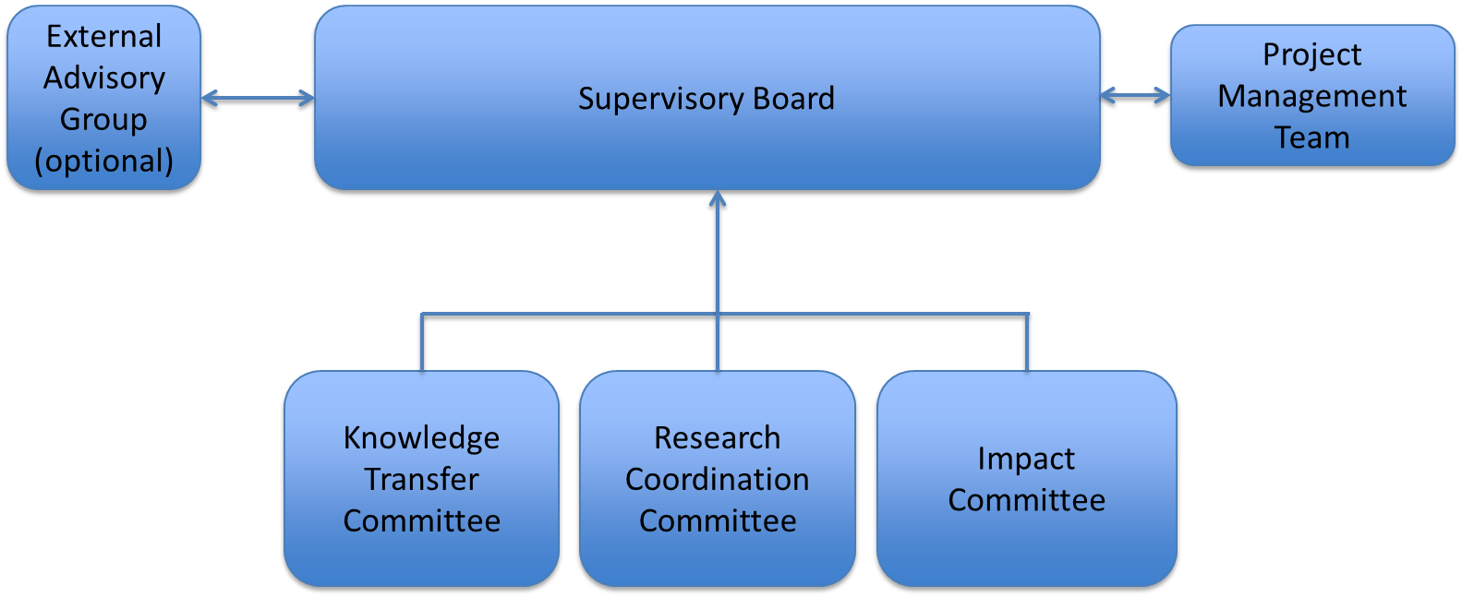

The tasks which should be carried out by the management structure include (list not exhaustive):
- Describe the financial management strategy – resource planning and allocation of finances. Ensure it is clear that the financial resources are allocated transparently and efficiently across the consortium so that the money is linked to the delivery of the programme. Include a description of which institutional departments will help with managing the programme (Finance, Research Office) and what their experience is e.g. number of FP7/Marie Curie/H2020 projects managed (NB for the Coordinator).
- Describe the internal communications strategy to keep the consortium in regular contact e.g. intranet or other document repository, regular face-to-face and/or virtual meetings.
- Describe how the rules for Intellectual Property across the consortium will be set down in the Consortium Agreement. Explain how you will monitor the creation of any IP, how you will exploit it and who in your institution will help with this e.g. Technology Transfer Office. Adhere to the IP rules in the MSCA Grant Agreement – summarized in a booklet from the IPR helpdesk.
- Describe the preparation and use of a Data management plan (only if participating in Open Research Data pilot.)
  - “Open Data: beneficiaries will engage in research data sharing by default, as stipulated under Article 29.3 of the Horizon 2020 Model Grant Agreement (including the creation of a Data Management Plan). Participants may, however, opt out of these arrangements, both before and after the signature of the grant agreement. Note that information related to Open Research Data provided in the proposal will not be subject to evaluation. In other words, proposals will not be evaluated negatively because they opt-out of the data sharing.”
  - Concise information on the Data Management Plan and the Open Research Data pilot can be found in the Horizon 2020 Online Manual at http://ec.europa.eu/research/participants/docs/h2020-funding-guide/cross-cutting-issues/open-access-dissemination_en.htm
  - Describe who will be responsible for preparing and maintaining the Data Management Plan – be sure to add the DMP as a Deliverable in Section 4.1

4.2.2. Elaborate on quality management, relating to the availability of adequate resources of the coordinating organisation in support of the day-to-day management of the project in accordance with the obligations described in the Grant Agreement.
- Monitoring progress and quality – e.g. frequency of reports from the participants to the Supervisory Board or sub-committees, frequency of interaction between the Staff members and the lead researcher in the organisation. Address the issue of overall quality assurance – will there be external review/monitoring of the RISE by an independent panel/external advisory group?
- Strategy for dealing with Scientific Misconduct: What would you do if a participant accused another of Falsification, Fabrication or Plagiarism? What processes are in place in the participants to deal with misconduct? How will the consortium link with the individual beneficiaries’ processes for investigating misconduct? State that the consortium will abide by the European Code of Conduct for Research Integrity.

4.2.3 Consider the risks that might endanger reaching the action’s objectives and the contingency plans to be put in place should risk occur.
- Complete the table provided with research and project management risks. Be sure to include risks for all WPs, not just the management ones. It’s important to show that you have considered the research risks.

Table B3c – Risk List
Risk No | Description of Risk | WP Number | Proposed mitigation measures
R1 | e.g. delay in planned secondments

Common Weaknesses in unfunded RISE applications:
- The management structures and procedures are not sufficiently detailed. In particular, the measures to achieve efficient management communication are not adequately specified.
- The decision making mechanism and conflict resolution schemes are insufficiently detailed.
- The periodic reports are scheduled for only once per year, which is limited for the scale and duration of the project.
- Arrangements for practical support for the detached and incoming staff are not sufficiently considered.
- The risk management and contingency plans lack detail or are missing. Personal, technical risks and associated contingency actions are not adequately identified. IPR issues are not properly addressed. Please note: It is not realistic to classify all the risks associated with the project as low risk.
- The quality management issues are not adequately addressed. For example, the Management board is described and it is described how it intends to mediate in case of conflicts, but it is not discussed in sufficient detail how it intends to monitor the quality of the project in practice.
- The involvement of the participants in managing and monitoring of the project is not adequately described, and processes for overall evaluation of progress are not sufficiently addressed. Responsibilities lie largely with the coordinator, without devolvement of duties to work package leaders, which is not appropriate for a consortium of this size.
- The management procedures are described in inadequate detail, e.g. the frequency of meetings of the board is not specified.

4.3 Appropriateness of the institutional environment (hosting arrangements, infrastructure)
Please develop your proposal according to the following lines:
- Explain the availability of the expertise and human resources, to carry out the proposed research action as well as the hosting arrangements/infrastructure.
- Describe the necessary infrastructures and any major items of technical equipment (if required) relevant to the proposed action.
- If applicable, include and list in Table B3d the beneficiaries/partners organisations that will participate together with other entities under a capital link and shortly describe the legal arrangement and the roles of each affiliated entity in the proposal (i.e. the tasks and the secondments allocated to affiliated entities should be included)
The aim here is to explain who is doing what, and show that they have the necessary infrastructure to do it.
- Section 5 will include a Capacities Table for each participant.
- This section should complement Section 5 not duplicate it.
- Describe how the consortium has the necessary infrastructure (research and administrative) to implement all aspects of the programme (research, training, admin, communications, exploitation etc.).
- Describe how the participants provide an excellent environment for hosting and supporting the Staff who visit them such as help with finding accommodation, with immigration and other practical matters, including:
  - Affirming that the EURAXESS Service Centres will assist with mobility issues. There are >200 service centres in 40 countries. See https://euraxess.ec.europa.eu/information/centres/search All Irish HEIs are EURAXESS Local Contact Points and have a designated person who can help visiting researchers.
  - Have the organisations endorsed the Charter & Code – if yes, say so! List at https://euraxess.ec.europa.eu/jobs/charter
  - Have the organisations earned the “HR Excellence in Research” logo? If yes, state this and include the logo in the Capacities Table! List at https://euraxess.ec.europa.eu/jobs/hrs4r

Table B3d – Secondments allocated to affiliated entities
WP | Task name | Staff member profile (ER/ESR/MNG/ADM/TECH) | Beneficiary /partner short name | Affiliated entity short name | Country of the affiliated entity | Person-months allocated
Common Weaknesses in unfunded RISE applications:
- The appropriateness of the institutional infrastructure has been insufficiently addressed.
- The infrastructures of some non-academic participants are only briefly described. Some necessary equipment is not fully described.

4.4 Competences, experience and complementarity of the participating organisations and their commitment to the action
Please develop your proposal according to the following lines:
- Describe the adequacy of the consortium to carry out the action by explaining how participating organisations' synergies and complementarities will be exploited.

NB: The individual members of the consortium are described in Section 6. There is no need to repeat that information in this section.
- Explain how the consortium are the best people to implement this programme including:
  - Complementarities/synergies in expertise between all participants and how this complementarity allows them to successfully deliver the programme (use a diagram or table).
  - How their previous experience makes them suitable for their tasks here
- Outline the commitment of each participant by showing that they are all highly active in the project – refer to earlier sections – use a table.
- For TC participants, refer to contents of Letters of Commitment from each TC participant – the proposal text must match the Letter.
- Particularly important for high-income TC contributing their own budget – they should make a financial commitment in the letter.

Common Weaknesses in unfunded RISE applications:
- The partnership brings complementary expertise to the project, however it is not sufficiently clear how the resulting synergies are to be exploited.
- Competences and experiences of the non-academic partner have not been specified in sufficient detail.
- The complementarity of the different partners is not sufficiently detailed.

STOP page count – MAX 30 pages

5. References
Add all relevant references in a standard scientific citation form.

6. Participating organisations
Note that:
- Any inter-relationship between different participating institutions or individuals (e.g. shared premises or facilities, joint ownership, financial interest, overlapping staff or directors, family-ties, etc.) must be declared and justified in this part of the proposal;
- All information provided (including table B4) must be based on current data, not on projections; For the annual turnover, approximations are acceptable and any other additional explanations to help assess operational capacity.
- The data provided relating to the capacity of the participating institutions (“Operational Capacity” – particularly relevant for non-academic organisations) will be subject to verification during the grant preparation phase;
- The absence of sufficient information in this section may be considered by the REA as a ground to disregard the participation of an organisation based on insufficient operational capacity.

General Reasons for Failing Operational Capacity:
1. The proposal does not offer sufficient description and evidence of participants' operational capacity (including those of the project coordinator).
2. Participants’ capacity to provide training on the topics outlined in the proposal is not substantiated.
3. The research work plan is insufficiently detailed.
4. Activities related to knowledge sharing are presented at a very basic level without necessary details.
5. Secondments are not appropriately shared amongst participants in alignment with the proposed research programme.
6. Secondments are not appropriately aligned with participant capacity. E.g. A beneficiary with small capacity has been allocated a high proportion of the total secondment person months.
Non-academic beneficiaries:
Many of the proposals which fail the operational capacity check do so owing to the failure of non-academic participants in the consortium. The operational capacity of non-academic beneficiaries can be questionable on the basis of:
- A low number of employees/Inadequate human resources.
Who will supervise secondees during their secondment at the auspices of the company? In the case of a non-academic beneficiary with few fulltime employees, how will the company business be run when an employee from this beneficiary goes on secondment?
- A low annual turnover.
In several cases the project budget allocated to a beneficiary was higher than the turnover of the company in one year.
- A new company with no financial history.
A SME / start-up with an annual turnover of 0 will not pass the operational capacity check.
- A lack of significant outputs in the relevant research field.
Non-academic beneficiaries should demonstrate that they have experience in the appropriate research area. Examples could include publications, patents, trade secrets or an actual product/service that is related to the research area.
- Not enough space for all declared employees and secondees to work together.
Reviewers took note of the physical space of non-academic organisations (in sqm) and judged whether this could realistically support the proposed number of staff / secondees.
- Lack of clarity with regards to independent research facilities

Table B4 – Data for non-academic Beneficiaries
Name | Location of research premises  (city/country) | Type of R&I activities | No. of full - time employees involved in the project | No. of employees in R&I | Web site | Annual turnover (approx. in Euro)

- Important! This table is mandatory to correctly assess the operational capacity of non-academic beneficiaries.

All organisations (whether Beneficiaries or TC Partner organisations) must complete the appropriate table below. Complete one table of maximum one page per Beneficiary and half a page per TC Partner organisation. The experts will be instructed to disregard content above this limit (Min font size: 9).

Table B5 – Organisations (Beneficiaries and TC Partner organisations) data
Beneficiary (Organisations in EU MS/AC) Legal Name
General Description  Include HR Excellence in Research and/or Athena SWAN logo here if applicable | Add a general description of the beneficiary and a short description of the actual centre/department/school participating in the action
Role and Profile of key people | Include names, qualifications of the person(s) supervising the action.
Key Research Facilities, Infrastructure and Equipment | Demonstrate that the team has sufficient resources to offer a suitable environment to seconded staff and to significantly contribute to the research/innovation activities proposed.
Independent research premises? | Please explain the status of the Beneficiary's research facilities – i.e. are they owned by the Beneficiary or rented by it? Are its research premises wholly independent from other Beneficiaries and/or TC Partner organisations in the consortium?
Previous Involvement in Research and innovation actions | Describe relevant research/ innovation actions in which the organisation took part
Current involvement in Research and Innovation actions | Describe relevant research/ innovation actions in which the organisation is currently participating
Publications and/or research/innovation products | Max 5  For non-academic organisations, do not leave this blank. It could be publications, patents, policy interventions, trade secrets, new products (including software) or processes…

Partner Organisations in TC Legal Name
General Description
Role and Profile of key people | As above
Key Research Facilities, Infrastructure and Equipment | As above
Do you have independent research premises? | As above
Previous Involvement in Research and innovation actions | As above
Current involvement in Research and Innovation actions | As above
Relevant publications and/or research/innovation products | Max 3  For non-academic organisations, do not leave this blank. It could be publications, patents, policy interventions, trade secrets, new products (including software) or processes…

7. Ethics Issues
To assist with preparing this section, please consult the “H2020 How to complete your Ethics Self-Assessment” guide at http://ec.europa.eu/research/participants/data/ref/h2020/grants_manual/hi/ethics/h2020_hi_ethics-self-assess_en.pdf and the Ethics section of the Horizon 2020 Online Manual at http://ec.europa.eu/research/participants/docs/h2020-funding-guide/cross-cutting-issues/ethics_en.htm. If necessary, please consult with the ethics committee and/or data protection officer of your organisation before writing this section.
All research activities in Horizon 2020 should respect fundamental ethics principles, including those reflected in the Charter of Fundamental Rights of the European Union. These principles include the need to ensure the freedom of research and the need to protect the physical and moral integrity of individuals and the welfare of animals.
Research ethics is of crucial importance for all scientific domains. Informed consent and confidentiality are as important for a sociological study as they are for clinical research.

All proposals considered for funding will be submitted to an Ethics Review procedure.
Ethics Review is part of the overall H2020 Appraisal Scheme and Ethics Review concerns all proposals and actions including Ethics Screening and Ethics Assessment (if necessary). Under the H2020 Ethics Appraisal Scheme, Ethics Checks can be carried out during the action's implementation and for a period of up to two years afterwards.
When preparing a proposal, it is required to conduct an Ethics Self-assessment starting with the completion of an Ethics Issues Table (Part A). In this context, please be aware that it is the applicants’ responsibility to identify any potential ethics issues, to handle the ethics aspects of their proposal, and to detail how they plan to address them. Please refer to the Ethics Self-Assessment Guidelines under Horizon 2020.
If you have entered any ethics issues in the ethics issues table in Part A of the proposal, you must submit an ethics self-assessment in Part B2 Section 7.
Your self-assessment must:
1) Describe how the proposal meets the national legal and ethics requirements of the country or countries where the tasks raising ethics issues are to be carried out.
Should your proposal be selected for funding, you will be required to provide the following documents, if they are already in your possession:
- The ethics committee opinion required under national law;
- The document that is mandatory under national law notifying activities raising ethics issues or authorising such activities.

- Important! Note that according to the revised Art. 34.2 Grant Agreement, before the beginning of an activity raising an ethical activity, the appropriate ethics committee opinions required under national law or any notification/authorisation for activities raising ethical issues required under national and/or European law must be obtained. The documents must be kept on file and be submitted upon request to the Executive Agency. If they are not in English, they must be submitted together with an English summary which shows that the action tasks in question are covered and includes the conclusions of the committee or authority concerned.

2) Explain in detail how you intend to address the issues mentioned in the ethics issues table (Part A), in particular as regards:

- Research objectives (e.g. study of vulnerable populations, dual use, etc.);
- Research methodology (e.g. protection of any personal data collected, consent procedures, involvement of children, clinical trials, etc.);
- The potential impact of the research (e.g. dual use issues, environmental damage, stigmatisation of particular social groups, political or financial retaliation, benefit-sharing, malevolent use, etc.).
- Include a table explaining the task and the WP where the activities will be performed to fulfil the ethical requirements.

Make sure to follow the guidance provided in the ethics self-assessment guidance note when addressing the different issues raised by your proposal and keep in mind that all proposals selected for funding will undergo an ethics evaluation that will consider this section.

- Important! Please indicate which WP, deliverable, and/or task concerns the ethical issue you describe to avoid any unnecessary confusion during the Ethics Evaluation process.

8. Letters of Commitment of Third Country Partner organisations

Please use this section to insert scanned copies of signed letters of commitment from TC Partner organisations (see details Annex 4 - point 2 of the Guide for Applicants). The letter of commitment must explicitly refer to the proposal (call and acronym) as well as to motivate/explain the engagement to implement the secondments planned in the proposal. Please note that the letter must be signed by the legal representative of the concerned institution. Template provided in Annex 6 of the Guide for Applicants.
Ensure that the content of the Letter of Commitment from Partner Organisation precisely matches their stated tasks in the programme.

ENDPAGE

MARIE Skłodowska-CURIE ACTIONS

Research and Innovation Staff Exchange (RISE)
Call: H2020-MSCA-RISE-2018

PART B

“PROPOSAL ACRONYM”

3. Proposal Submission Process

A guide to the proposal submission process is outlined in the following sections:

Part 1. Participant Portal Log-in and RISE call page

Part 2. RISE Information and Submission Service

Part 3. Create a Draft on the Online Submission Service

Part 4. Adding Participants

Part 5. Edit Proposal Forms

Part 6. Proposal Submitted Page

Part 1. Participant Portal Log-in and RISE call page

Step 1.1 Participant Portal

- To begin the submission process, go the Participant Portal homepage

- Log-in or if you do not have an account, you can register as shown in the image below.
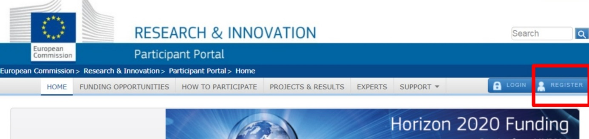

Step 1.2 Select the tab 'Funding Opportunities'

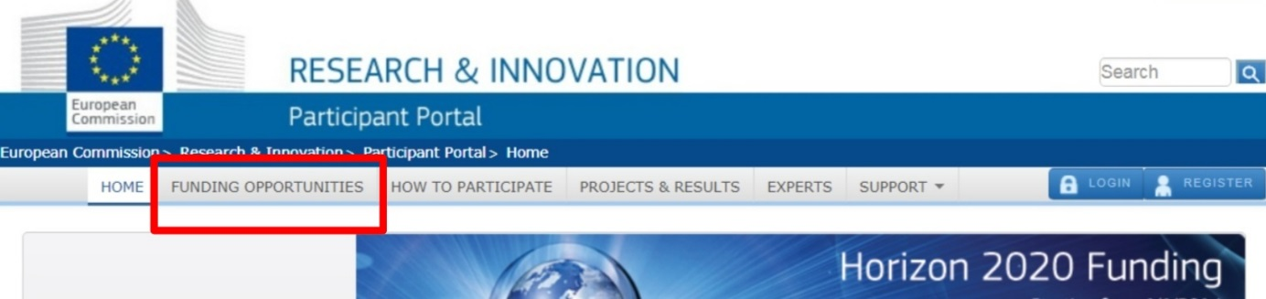
Step 1.3 Click ‘Search Topics’ as shown in the image below.

Step 1.4 Search directly for the Topic MSCA-RISE-2017.

- Enter key words such as ‘RISE’ into the Keyword Search
- You can filter your results by selecting the programme H2020

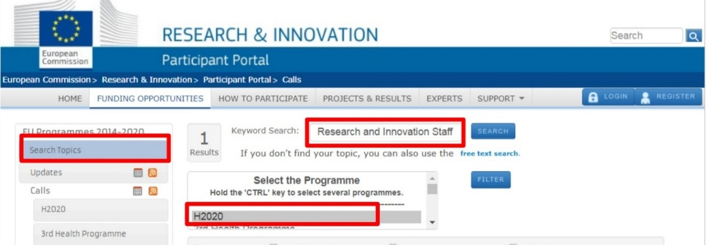

Step 1.5 Select the Topic MSCA-RISE-2018

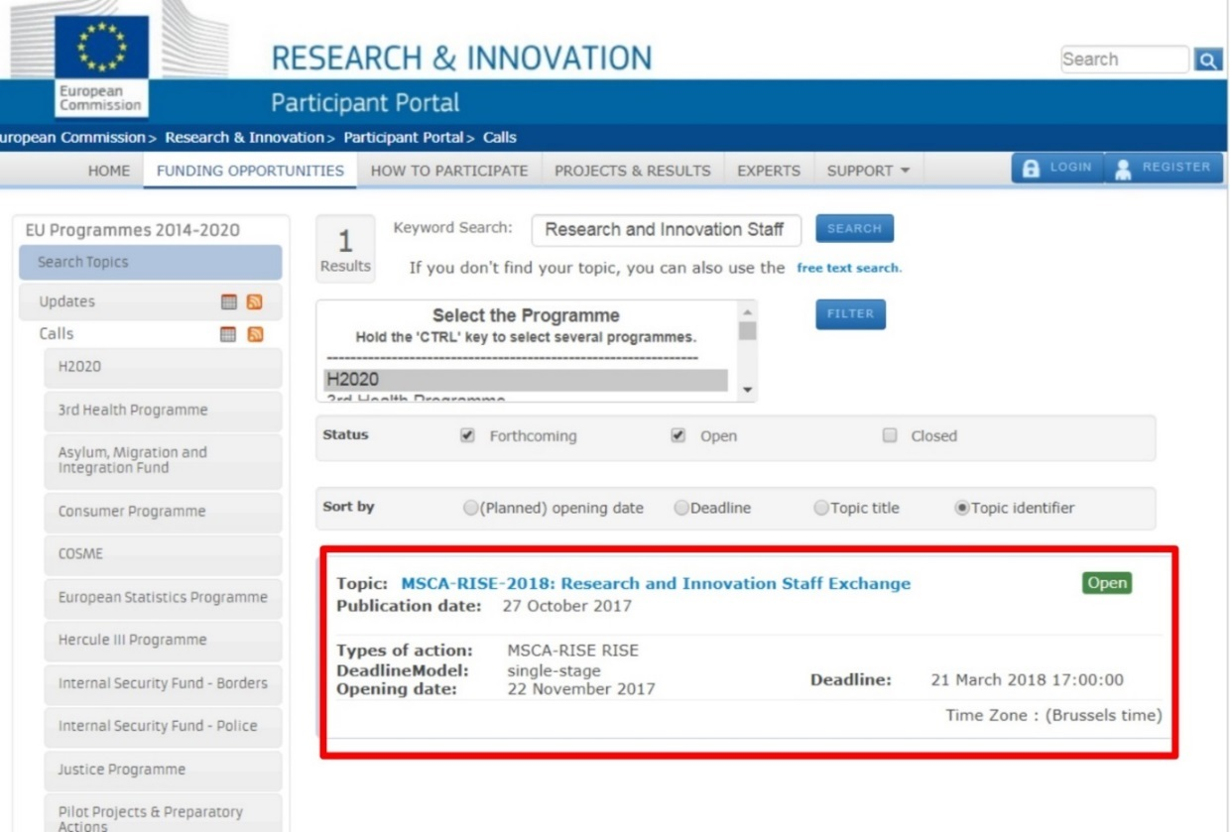

Part 2. RISE Information and Submission Service

Step 2.1 Navigating MSCA-RISE-2018 call page
- When you select the topic MSCA-RISE-2018-Research and Innovative Staff Exchange you will land on the page the official page for the topic MSCA-RISE-2017.
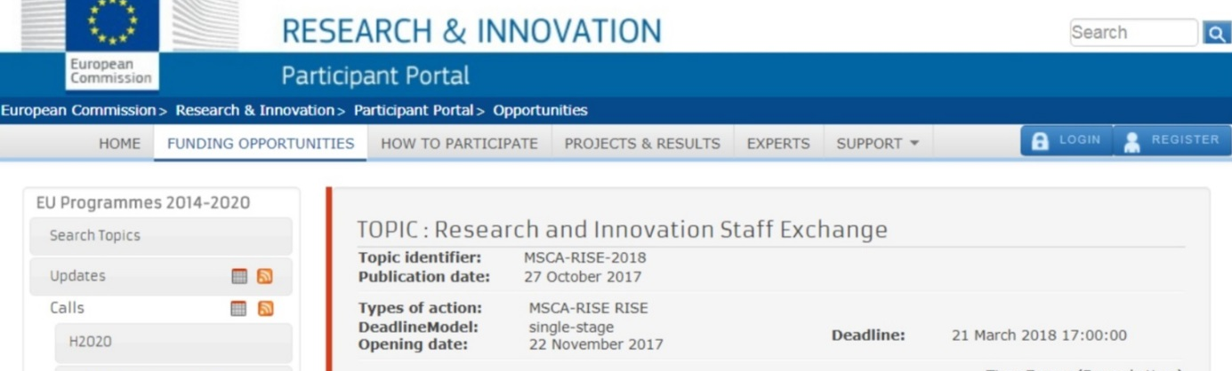

Step 2.2 Accessing RISE Information
The topic page contains the all the information about the call and access to the submission service. The following is available:

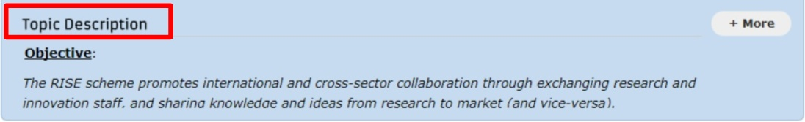
- Topic Description gives an overview of the call. Click on ‘More’ for information on the topic scope and background.

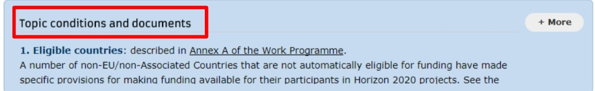
- Topic Conditions and documents provides further documents that relate to this call. If you click on ‘More’ you will able to access documents such as the Guide for Applicants and Frequently Asked Questions.

- Partner Search provides information on how to find partners for a RISE project and what organisations are looking for RISE partners.
- The Submission Service section on the topic page allows you to access the Electronic Submission Service. This is explained further in the next step.
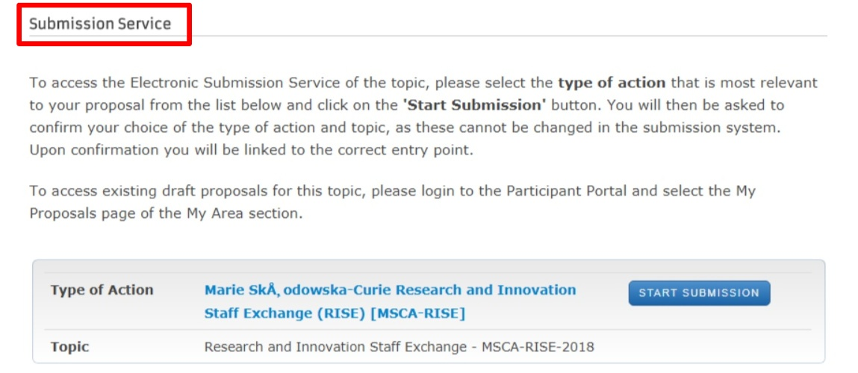

Step 2.3 Select ‘Start Submission’ for Marie Sklodowska Research and Innovative Staff Exchange (MSCA-RISE)

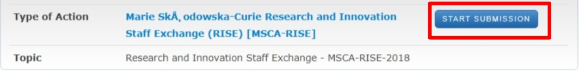

Part 3. Create a Draft on the Online Submission Service

Step 3.1 Create Draft

- Once you are on the Online Submission Service it should look like the screen shot below. This section is ‘Create Draft’ section.

- You can download the RISE application templates immediately (see Step 5.6)

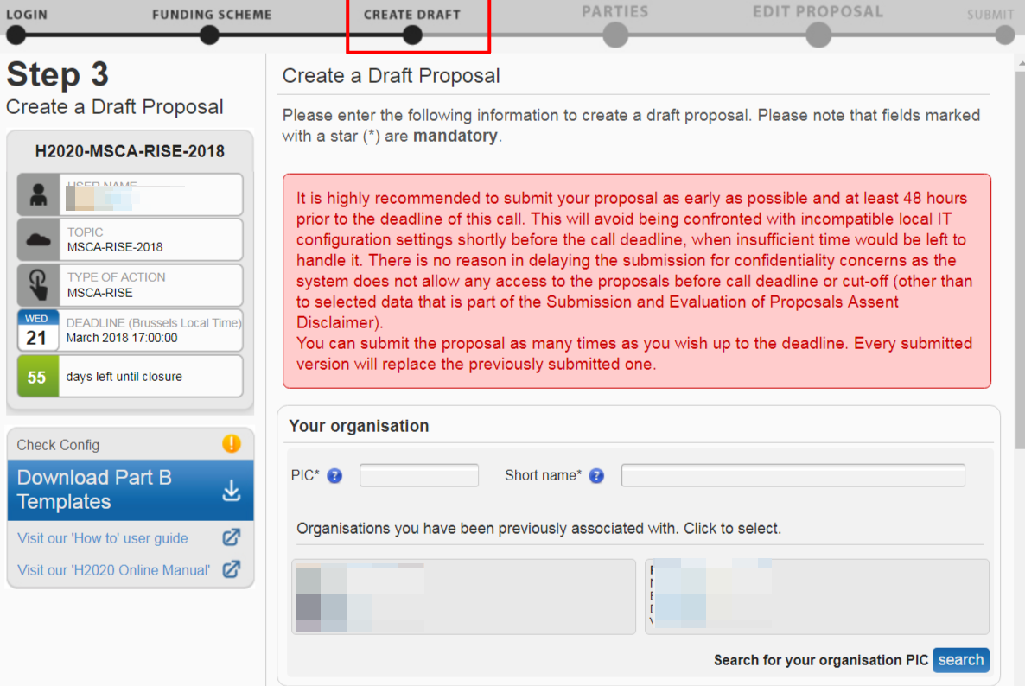

Step 3.2 Enter your organisation's PIC

- Entering the PIC will automatically populate the name field and highlight the address as shown in the image below.
- If you do not know the full PIC number of your organisation, you can search by name as shown in the images below.
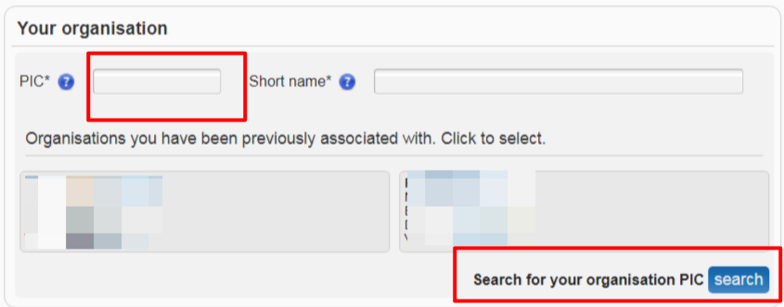

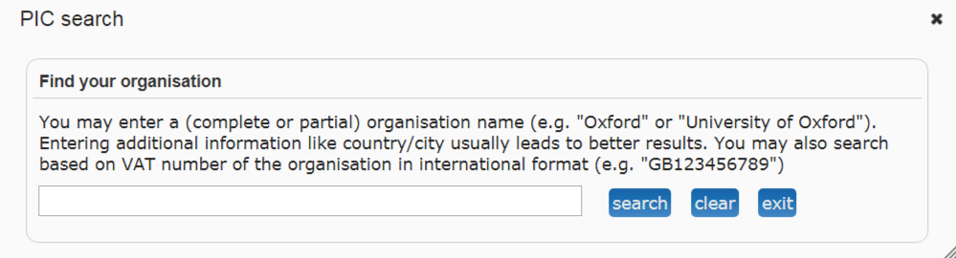

Step 3.3 Indicate your role in the proposal

- The Proposal Coordinator organisation should select the top-level role (Main contact) for during the initial proposal draft creation.

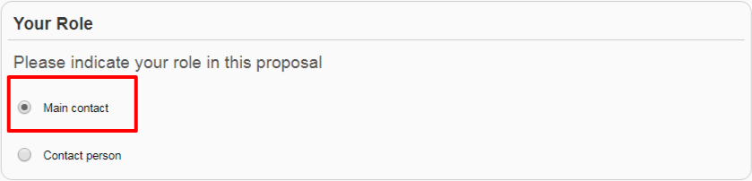

Step 3.4 Fill in the Proposal Details

- Acronym
- Short summary
- Select the appropriate Scientific Panel- The applicant chooses the panel to which the proposal will be associated at the proposal stage (using the field "Scientific Panel" in section 1 of the proposal submission forms) and this should be considered as the core discipline. Additional descriptors are used to define the other disciplines that may be involved.

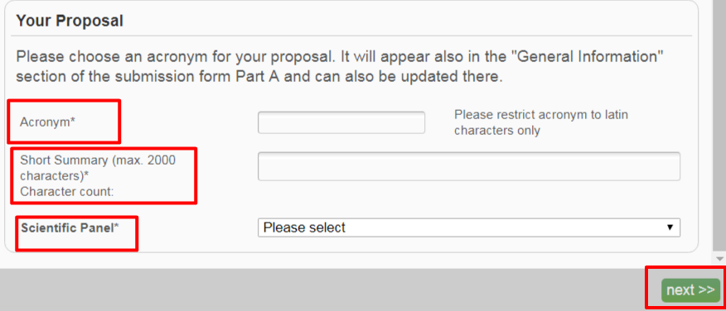

Step 3.5 Click Next

- This is shown in the image above.

Note:
When you add your organisation, the LEAR person in your organisation is informed about the involvement of their organization. You as the person who added the organisation will see this warning message. Click OK to this message:

Step 3.6 Disclaimer
You will be presented with the following Disclaimer – click to accept it and proceed, or to decline it and cancel the proposal submission:

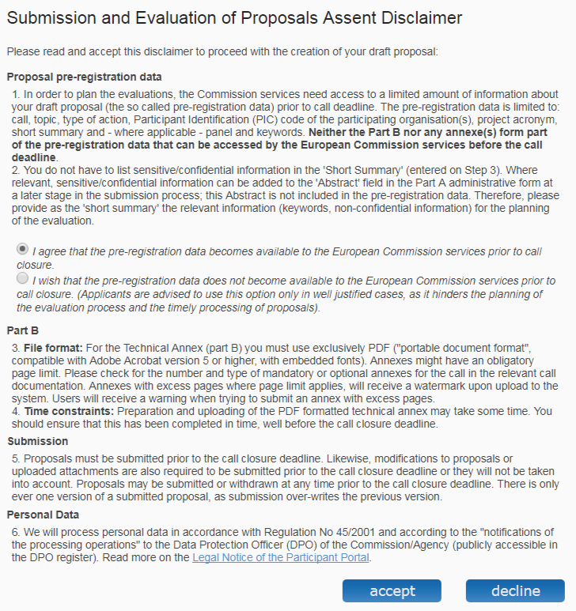

Step 3.7 Confirmation of draft proposal
- You should receive a message confirming that your draft proposal has been created. You will also receive a confirmation email.

Postpone Application Submission

- Before continuing with the proposal submission, you will get the following alert:
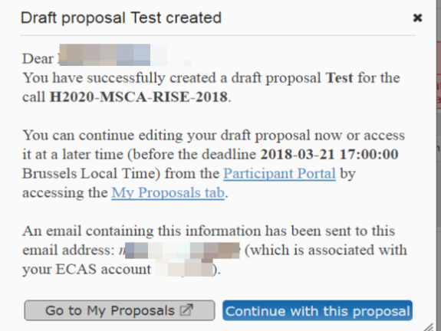

If you want to postpone completing the online submission for a later time you can leave and return later as follows:
- Click on or, to access a previously saved draft proposal form, go to the MY AREA > My Proposal(s) page in the Participant Portal (you must be logged in).
- Click on the “ED” button to access the draft as shown in the image below:

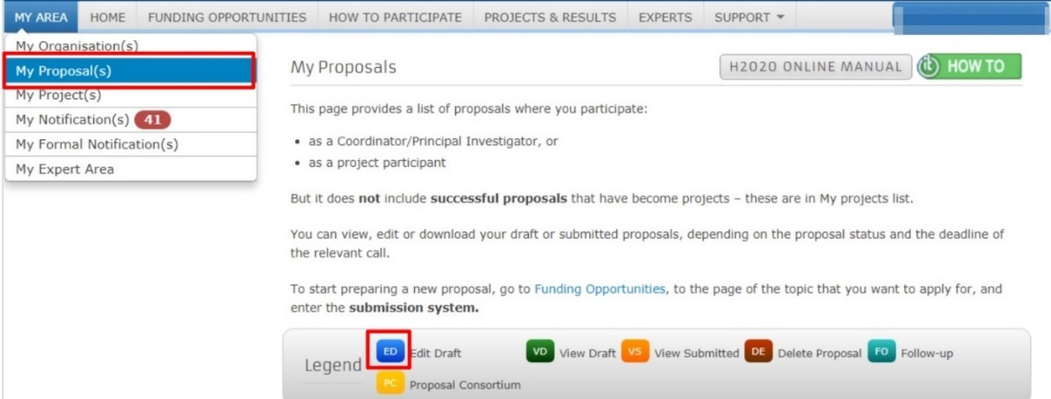

Part 4. Adding Participants

Participant Requirements

- The next stage of the Online Submission will be to add the various participants involved in the proposal. After completing section 3 ‘Create Draft’ you should now be on the next section called ‘Parties’ as shown in the screen shot below:

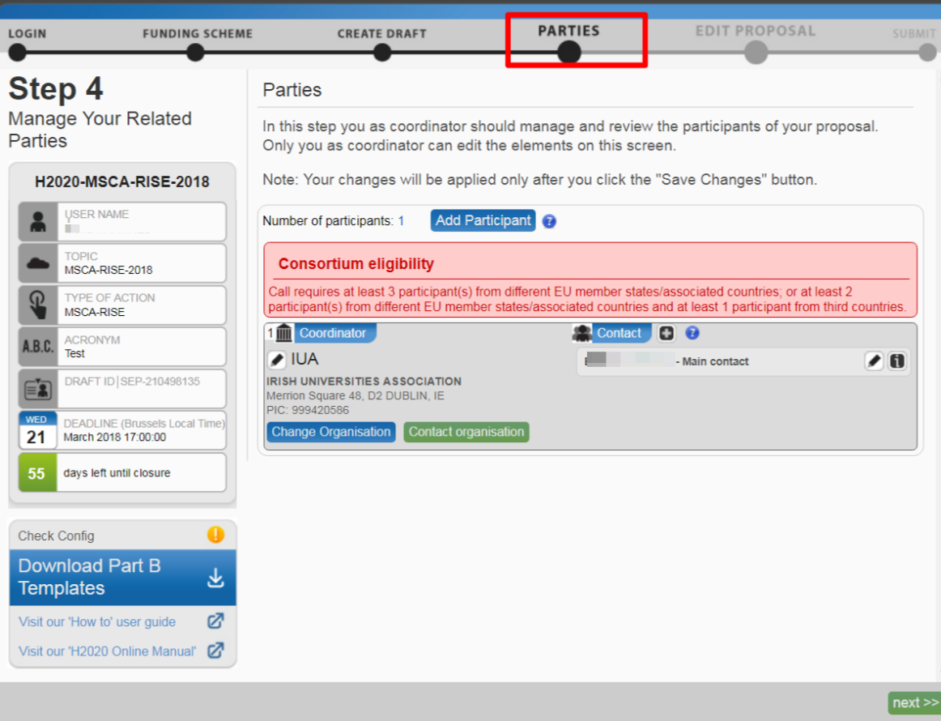

Step 4.1 Check Consortium Eligibility
- If you don’t have the correct beneficiary requirements relating to RISE, the following red warning sign will be apparent:
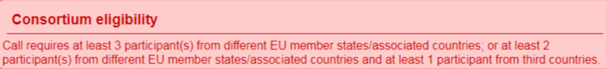

Step 4.2 Add Participant
- Click the tab ‘Add Participant’.
- Participant refers to all the organisations in your consortium, including those from Third Countries.

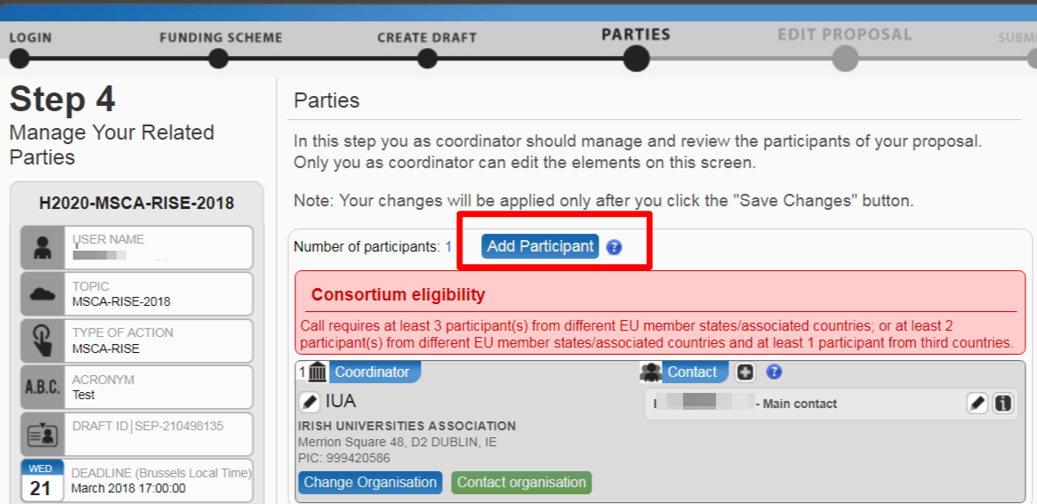

Step 4.3 Search for organisation
- You can search for the organisations as seen in the image below using their PIC number, organisation name etc.
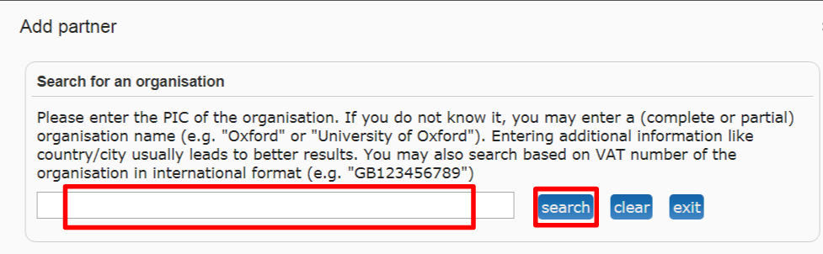

Note:

For a RISE action application, each participating organisation (Beneficiary and TC Partner organisation) has to register on the Participant Portal in order to receive a unique PIC number:

• Applicants should check carefully if a PIC number already exists for their organisation, to avoid duplications. If they already possess a validated PIC, it must be used when applying. (NB legal entities having a valid PIC number under FP7 maintain their PIC in H2020).

• Before final proposal submission, each participating organisation shall verify its status according to the definitions provided via the Participant Portal.

Step 4.4 Select the organisation
- Click the ‘use’ button on the relevant organisation.
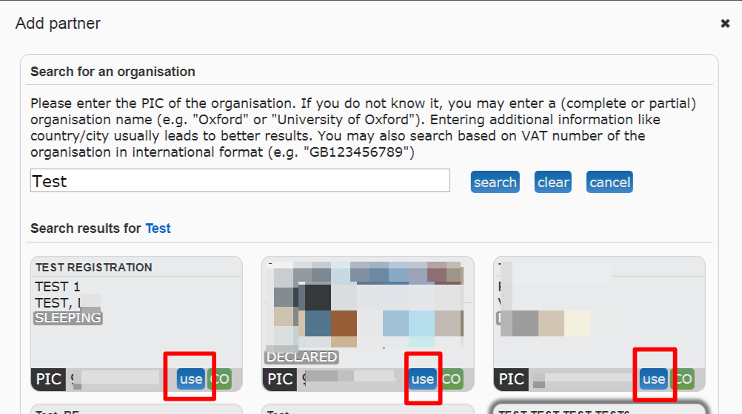

Step 4.5 Fill in the Add contact window
- Select the appropriate role for the participant. Ensure each participant has a main contact.
- If the main contact person does not have an ECAS account yet, the system will use the email provided for that contact to send them an invitation and grant ECAS access.
- If you need more information here select the question mark in the window.

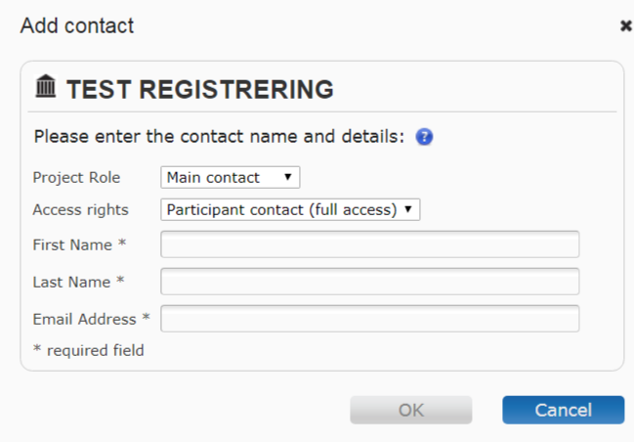

Editing organisation information
Once you add the participants you can perform the following actions:

- Delete participant
- Partner information
- Edit existing contact
- Delete existing contact
- Contact information
- Change organisation
- Contact LEAR
- The system will automatically generate emails to all the participant contacts. The emails include all relevant information and links to access the proposal. The Access rights granted to each participant contact will determine the level of access that the contact will have.
Note:
The Proposal Submission System checks automatically if the first and last names of the contact match the name details of the user currently logged in the active ECAS session. Adding a contact with a name that does not match the user name registered in ECAS will give you a warning message. The mismatching name details will then be circled in red colour. If you receive such a message, it probably means that the information provided does not match the information registered in the ECAS account.

Step 4.6 Save change and continue

- Once you add all the participating organisations you should save changes as indicated in the image below.
- Click next to move on to the next stage “EDIT PROPOSAL”.

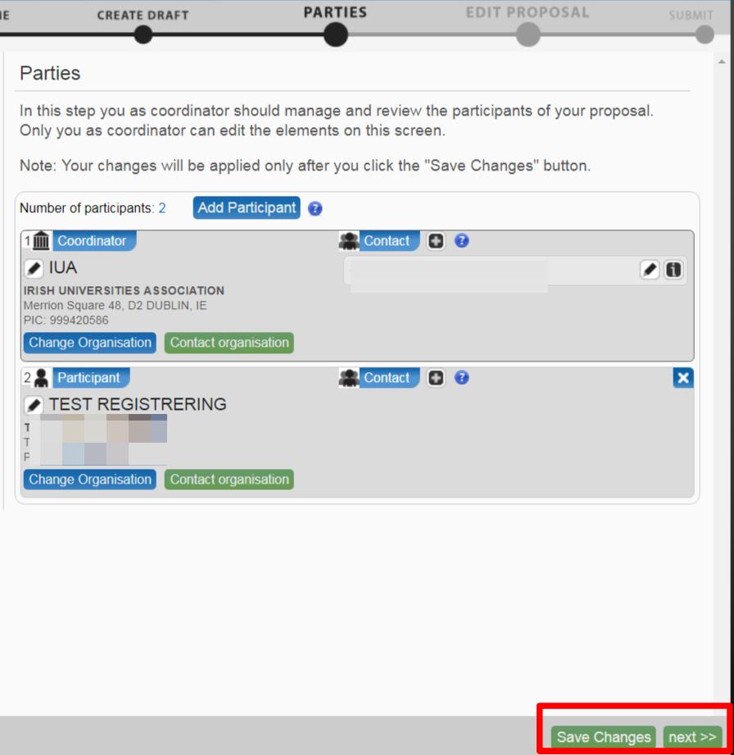

Part 5. Edit Proposal Forms
- The next section on the Online Submission is the ‘Edit Proposal’ section. This is where you fill out the forms required.
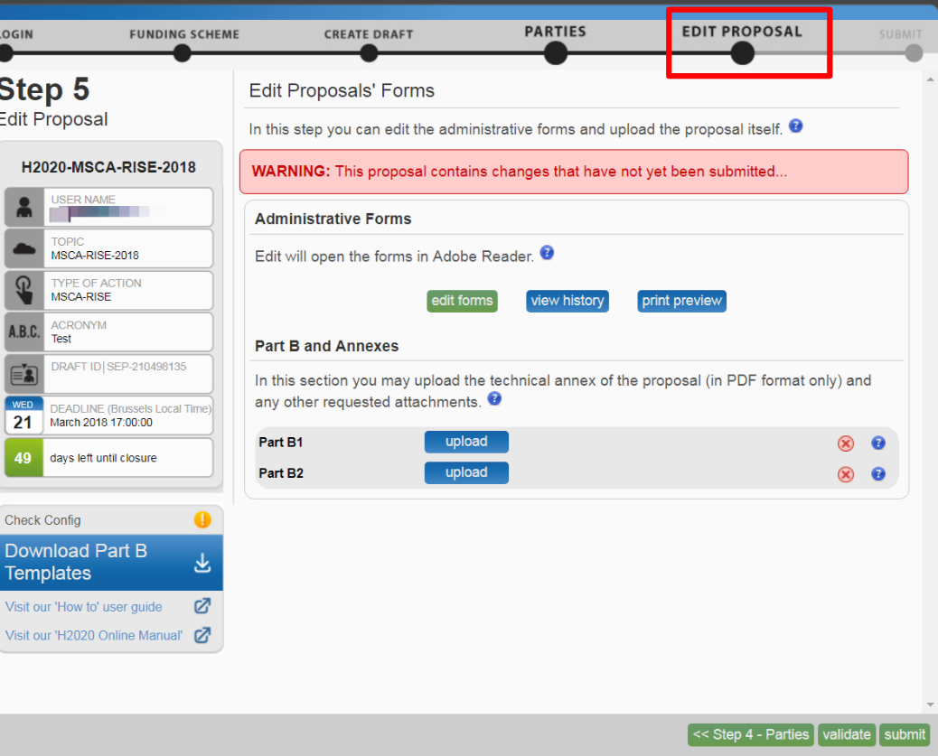

Step 5.1 Ensure you are familiar with the information required.

Form | Information
Part A forms (Administrative forms) | - Section 1: General information about the proposal (including abstract)  - Section 2: Data on participating organisations  - Section 3: Budget and List of secondments (request for funding in terms of person-months)  - Section 4: Ethics table  - Section 5: Call specific questions
Part B (Proposal) | Part B Document 1  - Section 1-3  Part B Document 2  - Section 4-7
- The following table includes all the information required in the Part A forms and Part B (document 1 &2):

Step 5.2 Part A forms

- Applicants will be asked for certain administrative details that will be used in the evaluation and further processing of their proposal. Part A constitutes an integral part of the proposal.
- The proposal coordinator has the rights to edit all sections of the administrative form, participants can only update their relevant sections - including the budget form.
- Click on “edit forms” to access the Administrative forms (Part A forms) which will open in Adobe Acrobat (See step 5.3 below):

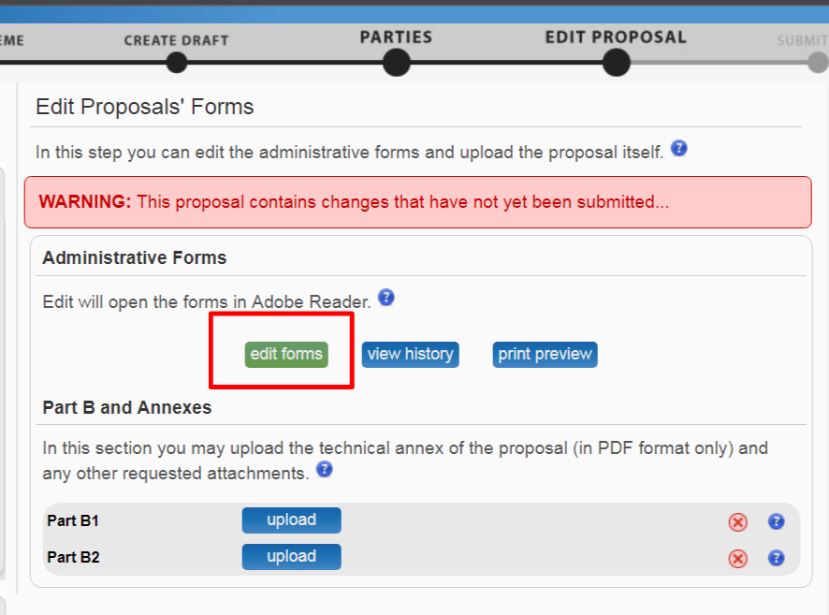

Step 5.3 Adobe Connect

- The administrative form (Part A) requires Adobe plug-in support.
- If you have a browser/OS combination which offers an Adobe Acrobat browser plug-in, then the forms will open within this browser session.
- As can be seen in the image below, if your browser/OS does not support a plug-in then the forms will open in a separate Adobe Acrobat window.
- In order to be accessible offline, the form must be downloaded, edited and saved within 2 hours. This can be repeated multiple times

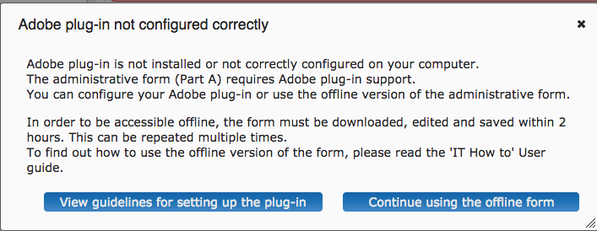

Note:
- If you continue using the offline form you will get the following message if your Adobe Reader needs an update:
- “The document you are trying to load requires Adobe Reader 8 or higher. You may not have the Adobe Reader installed or your viewing environment may not be properly configured to use Adobe Reader.”

- The following table shows the operating systems and browsers actively supported by the system, as well as the Adobe Reader version required for each configuration:
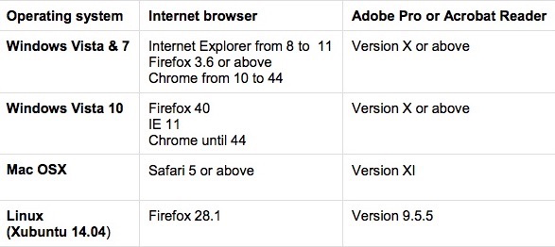

Step 5.4 Edit and Complete Administrative form

- Begin completing the form by scrolling down or clicking the blue button to navigate to the respective section of your form.
- This is primarily an administrative form that should include general information, administrative data of participating organizations, secondment details, budget information by partner, and also Call-specific information.
- Two action buttons in the PDF form help you find and verify the information easily. These Action buttons ‘Validate form’ and ‘Save and Close’ will be outlined in the steps below.

Step 5.5 Validate Form

- You must click the button to make sure that your application meets the administrative requirements. The form will run a self-check and prompt you in case of errors or warnings.
- When all errors are corrected, the validation test will confirm that there are no errors as shown in the image below.

Step 5.6 Save and Close

- When all issues are fixed, click the ‘save and close ‘button. Your form will be saved on the Commission servers, but it is not yet submitted. Your proposal submission takes place next.
- You may return to edit the form as many times as you wish before the closing date of the call. Any changes saved on the form need to be resubmitted in order to be received by the European Commission and considered for evaluation.

Step 5.7 Part B Templates

Download Part B Templates as shown in the image below. The templates are available to download as shown in the image below. This will download the required proposal templates in a readily editable rich text format (RTF) file:
- H2020-MSCA-RISE-2017 Part B1 - Document 1
- H2020-MSCA-RISE-2017 Part B2 - Document 2

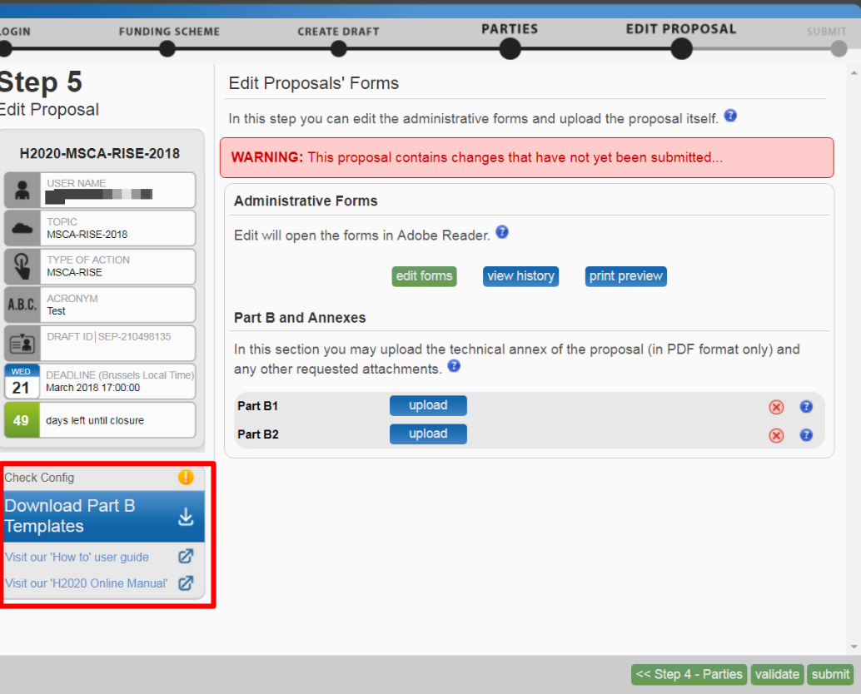

Step 5.8 Complete the templates

- The templates describe the information that must be included in your application and how to structure that information.
- This RISE handbook goes through the key information for these sections.

Part B Templates
H2020-MSCA-RISE-2018 Part B1 - Document 1 | H2020-MSCA-RISE-2018 Part B2 - Document 2
2. Excellence | 5. References
3. Impact | 6. Participating Organisations
4. Quality and Efficiency of the Implementation | 6. Ethics Issues
 | 7. Letters of Commitment of Third Country Partner organisations

Step 5.9 Uploading Preparation

- When you complete the Part B Document 1 and Document 2 described above, the following requirements described need to be met
- The breach of certain requirements, could result in failure of the upload – as a result you may need to amend the documents and upload them again.

- Check the page number limit and proposal template.

- If you exceed the page number limit, you will be still able to upload the document but all of the excess pages will contain a watermark. Your proposal will be considered ineligible if any one of these formal requirements is not met.
- After the deadline, any excess pages will be overprinted with a ‘watermark’, indicating to evaluators that these pages must be disregarded.
- The image below taken from page 36 in the MSCA RISE Guide for Applicants 2018 shows the page limit requirements for Part B Document 1 and Document 2. Double check you have the correct page limits:

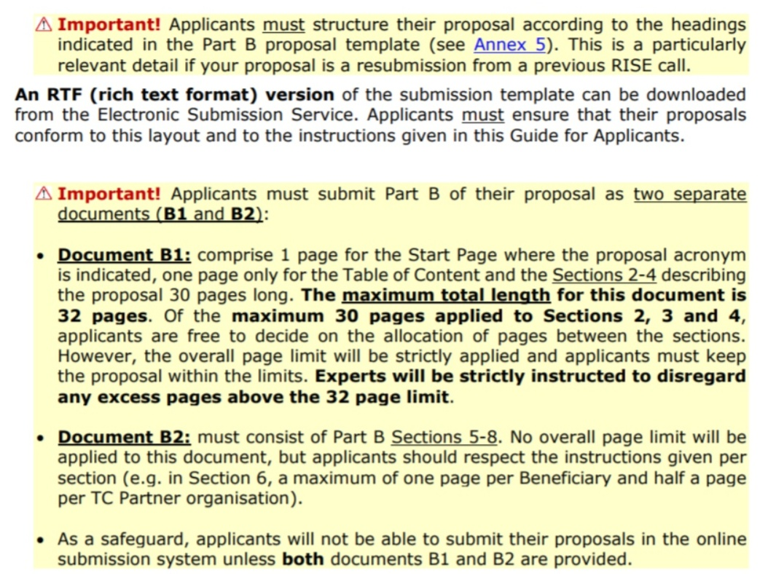
- Formatting Requirements

- The image below shows the RISE Part B form template with detailed instructions on the font size, literature references, numbering, file format.
- The following image was taken from the MSCA RISE Guide for Applicants 2018:
- You must ensure the limitations and requirements are in place for uploading. These are described in the next steps.
- Once the downloaded templates have been completed and all the formatting requirements have been met you can upload the templates.

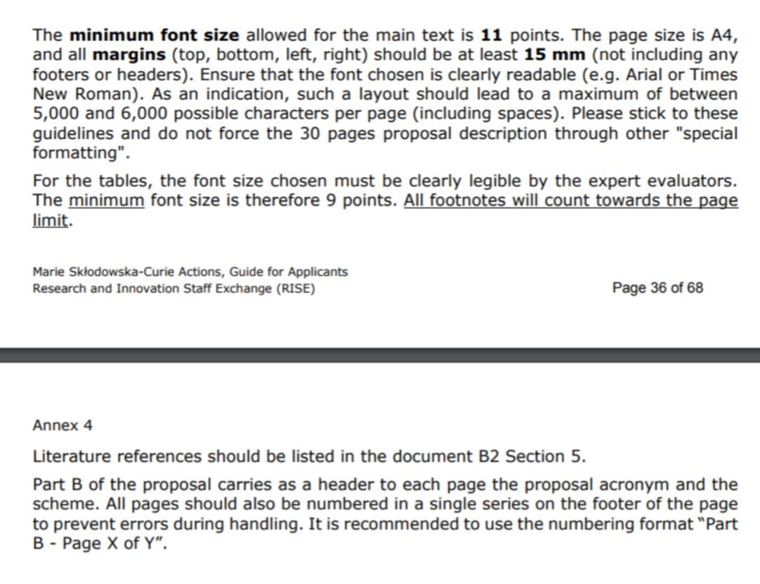

- Graphical resolution

- Use a maximum resolution of 300 dpi for all graphics and text (photocopy quality). This can dramatically reduce the PDF file size.

- Printer-friendliness

- Proposals will be printed out in black-and-white colour on plain A4 paper. If you have used other colours in your annex forms, make sure that they are correctly interpreted and visible as nuances of grey in the output PDF file.
- Ensure that printing is done at 300 dots per inch and that no scaling is applied to make the page "fit" the window.
- Print a test copy of your PDF files before uploading them.

- Document file name and security

- Ensure that the annex forms file names contain alphanumerical characters only (A-Z, 0- 9).
- Do not protect the uploaded files with a password.

- Post-upload verification

- Once you upload your files, check their quality - download them to check whether the file transfer was successful and if the file is complete. If not, make the necessary corrections and upload again.
Note:
Make sure that the files you upload can be opened and printed without any problems! If the Commission encounters a problem when opening or printing a file you have uploaded as part of a proposal, the complete proposal will be considered ineligible.

Step 5.10 Convert to PDF

- Once you have completed your proposal based on the downloaded template, you must convert it into a PDF file, which you will then upload as an Annex form of the proposal. This is referred to as Part B of your proposal.
- Other file formats will not be accepted by the Electronic Submission Services of the Commission.
- Pay attention to the page limits and maximum file size of documents to be uploaded since this may block the submission and lead to delays or missing important deadlines.
- Keep in mind that preparation and uploading of the PDF formatted technical annex may take some time. You should ensure that this has been completed in time, well before the call closure deadline.

Step 5.11 Uploading Templates

- Select the completed PDF files (Part B1 & Part B2) to upload as shown in image below.
- If your file has blank spaces in its name, the system will upload it filing the blank spaces with "_".

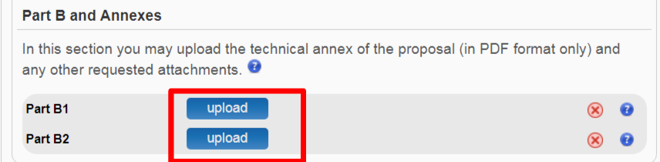

- The uploaded file will be shown in the list and a green check mark will appear next to it, as shown in the picture below.
- Optionally, you can delete the uploaded file and replace it with a new file.

Note:
If the file uploaded is not in a valid PDF format, an error message will appear instead of a confirmation mail.

Step 5.12 Validate & Submit

- To make sure that your application meets the requirements click the ‘validate’ button.
- In order to make your application meet the requirements of partners, file sizes, number of pages, etc., you will be prompted to correct any errors that have been detected in the forms.
- When all errors and warnings are corrected, click the button again to make sure you have not missed anything.
- Once you get the No Errors validation screen, click on the ‘submit’ button. Your proposal has now been submitted and the system displays a message to confirm that the proposal has been received:

Step 5.13 Confirmation email

- The Submitted status will also be shown on the My Proposals page of the Participant Portal.
- The Proposal Coordinator will also receive a submission confirmation e-mail, including details about the submitted proposal. Note that the e-mail could end up in the spam folder or get blocked by the antispam software of your organisation, so make sure that you check your inbox regularly.
- The submission is completed when the Proposal Coordinator clicks, and receives an email confirming that the proposal has been received.
- Uploading the documents itself does not finalise the submission process so it is important to upload your proposal as early as possible.
Note:

You can upload your Annex documents or submit your proposal as many times as you wish prior to the call deadline, but it is strongly advised not to wait until the last few days to do so. Each time you upload a new Annex document, you must click to save your changes.

Part 6. Proposal Submitted Page

The 'Proposal Submitted' Page means that your proposal has been successfully submitted and therefore sent to the European Commission services for evaluation. Once your proposal has been submitted you can carry out the following actions:

- Revise (Re-edit) the Proposal

- If you need to revise your proposal, click the button to go back to ‘EDIT PROPOSAL”.
- The Proposal Coordinator may continue to modify the proposal and submit revised versions overwriting each preceding one right up until the deadline.

- Download Submitted Proposal Package
- After submission of the proposal, it is advised to download your proposal in order to check that it has been correctly submitted.
- A digitally signed and time-stamped version of the latest submitted version of your proposal can be viewed/downloaded.
- Withdraw Submitted Proposal

- If the proposal is withdrawn, it will not be considered for evaluation. However, the system will keep the proposal draft and the withdraw action may be reversed by re-submitting the proposal before the specified deadline.
- You will have to enter a reason for the withdrawal. When a proposal is withdrawn, a message is displayed on the screen, as shown in the picture below. The system also sends a submission confirmation e-mail to the Proposal Coordinator, including the details of the withdrawn proposal.
- Note that the e-mail might get lost in your spam folder or get blocked by the anti-spam system of your organisations, so make sure that you check for it as needed.

A work package is defined as a major subdivision of the proposed project
ER = Experienced researcher, ESR = Early stage researcher, MNG = Managerial staff, TECH= Technical staff, ADM = Administrative staff. See Definitions section in the Guide for Applicants for more information.
Insert short name of sending organisation
Insert short name of hosting organisation
Suggested examples – not exhaustive
Suggested examples – not exhaustive
http://ec.europa.eu/research/participants/docs/h2020-funding-guide/cross-cutting-issues/climate-sustainable-development_en.htm
http://www.un.org/sustainabledevelopment/sustainable-development-goals/
https://www.iprhelpdesk.eu/FS_IP_management_in_MSCA-H2020
http://totallydublin.ie/arts-culture/arts-culture-features/pint-of-science/
http://www.sfi.ie/engagement/sfi-discover/
http://ec.europa.eu/research/researchersnight/about_en.htm Note that ERN is a competitive call. Events organized for 2018 will be announced in Spring-Summer 2018.
Available at http://ec.europa.eu/euraxess/index.cfm/rights/europeanCharter
Available at http://ec.europa.eu/euraxess/index.cfm/rights/codeOfConduct
A "lead Beneficiary" must be a Beneficiary (= organisation established in a MS/AC) and cannot be a TC Partner organisation
Deliverable numbers in order of delivery dates. Please use the numbering convention <WP number>.<number of deliverable within that WP>. For example, deliverable 4.2 would be the second deliverable from Work Package 4.
A "lead Beneficiary" must be a Beneficiary (= organisation established in a MS/AC) and cannot be a TC Partner organisation
Please indicate the nature of the deliverable using one of the following codes: R = Document, report (excluding periodic and final reports); ADM = Administrative (ethics/legal/administrative related outputs); PDE = dissemination and/or exploitation of project results (website completion, patents filing, conference, etc.); OTHER = Other including coordination
Please indicate the dissemination level using one of the following codes: PU = Public: fully open, e.g. web; CO = Confidential: restricted to consortium, other designated entities (as appropriate) and Commission services; Important: please note that upon approval by the REA Project Officer, the deliverables with Public dissemination level (PU) will be automatically published on CORDIS, the European Commission's primary portal for results of EU-funded research projects. Therefore, make sure the content is appropriate both in terms of quality and confidentiality. CI = Classified: classified information as intended in Commission Decision 2001/844/EC.
Measured in months from the project start date (month 1).
A "lead Beneficiary" must be a Beneficiary (= organisation established in a MS/AC) and cannot be a TC Partner organisation
A "lead Beneficiary" must be a Beneficiary (= organisation established in a MS/AC) and cannot be a TC Partner organisation
Show how the consortium will confirm that the milestone has been attained. Refer to indicators if appropriate. For example: a laboratory prototype completed and running; software released and validated by a user group; field survey complete and data quality validated.
https://www.iprhelpdesk.eu/FS_IP_management_in_MSCA-H2020
Charter of Fundamental Rights of the European Union, 2000/C 364/01. See also http://www.europarl.europa.eu/charter/default_en.htm
http://ec.europa.eu/research/participants/data/ref/h2020/grants_manual/hi/ethics/h2020_hi_ethics-self-assess_en.pdf

