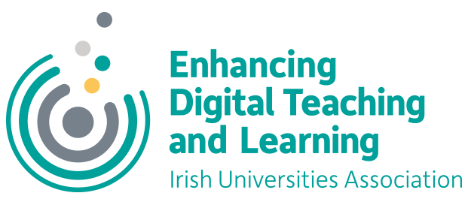

Student Associate Internship for Enhancing Digital Teaching and Learning in Irish Universities

The Irish Universities Association is currently looking to recruit a Student Associate Intern for the project: Enhancing Digital Teaching and Learning (EDTL) in Irish Universities. This is a fixed term internship for the period 1 July 2020 – 31 December 2020.
This is a part-time position, 15 hours per week, at a rate of €13.69 per hour. The IUA will aim to be as flexible as possible in relation to working arrangements. Under current restrictions, the role will initially involve working from home.
Enhancing Digital Teaching and Learning in Irish Universities is a project co-ordinated by the Irish Universities Association (IUA) and funded through the Higher Education Authority Innovation and Transformation Programme, aimed at enhancing the digital attributes and educational experiences of Irish university students. In the context of COVID 19 this is being done by supporting the digital skills of teaching staff as they transition to teaching in the online environment.
The goal is to empower those who teach to integrate appropriate digital technologies into their own pedagogies, teaching & learning, and assessment practices in effective and meaningful ways.
This is an excellent opportunity for the right candidate to expand their understanding of digital capacity in teaching and learning in Irish universities and the direct impact its future development will have on students and the student experience. Working alongside the rest of the project team, the successful candidate will play a key role in bringing the student voice to the project activities and communications.

The Role
Reporting to the IUA project manager, the student associate intern will be a full member of the project team.
Specifically, they will be expected to:
- act as a full member of the project team, including attending and contributing to project team meetings;
- liaise with project team members and student union representatives on each university campus;
- liaise with IUA staff members, including other student associate interns, the academic affairs team and the communications team;
- liaise with USI and National Forum student associate interns;
- run student-led social media for the project, in collaboration with student unions and campus student digital champions;
- contribute to project communications, including the project newsletter, podcast/video recording, presenting at events or panel discussions, provide comments for the media;
- support the activities of the project manager.
A Student Associate Internship Learning Contract will be drawn up between the student associate intern and the IUA to ensure clear expectations are set and that the partnership is beneficial to both parties.

Key Attributes
The candidate should satisfy a number of ESSENTIAL criteria:
- Be enrolled as a current student in one of the IUA universities or a recent graduate (within the last 12 months) of an IUA university
- Be able to commit to working 15 hours per week on the project
- Have a strong interest in the use of digital tools and technologies in teaching and learning in Irish universities

The candidate should also aim to satisfy the following DESIRABLE criteria:
- Demonstrable leadership skills
- Good organisational skills
- Strong written and oral communication skills and the ability to communicate effectively with both students and management in higher education

Contract details
This is a part-time position, 15 hours per week, at a rate of €13.69 per hour. The IUA will aim to be as flexible as possible in relation to working arrangements.
The position of student associate intern is a fixed term internship for the period 1 July 2020 – 31 December 2020, subject to meeting on-going performance requirements. The role may require some travel within Ireland, subject to COVID 19 restrictions. All reasonable and pre-approved travel costs associated with the internship will be covered by the IUA.

Application details
Please forward
- An up-to-date Curriculum Vitae
- A personal statement (not more than 350 words) clearly outlining what you feel you can contribute to the Enhancing Digital Teaching and Learning project and how this internship would support your own personal development
- A brief cover letter
by email to sharon.flynn@iua.ie by 5pm on Friday 5 June 2020

